**INFO GATHERING (OSINT)**

**------------------------------------------------------------------------------------**

* **Types of Information Gathering**
* **Passive Information Gathering**
* **SCANNING (Active Reconnaissance)**
* **NMAP**
* **MASS-Scan**
* **Enumeration**

**------------------------------------------------------------------------------------**

* **There are 2 types of Information Gathering** 
  + - 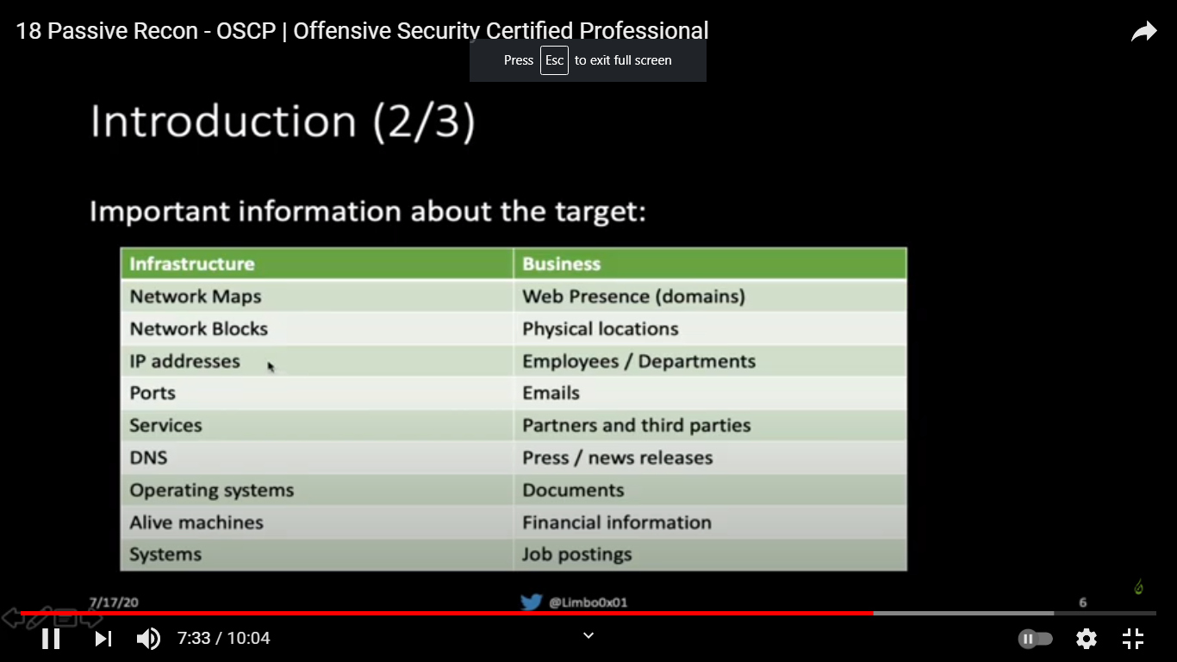
  + **passive Reconnaissance (FootPrinting)**
    - Passive Information Gathering (also known as Open-source Intelligence or OSINT) is the process of **collecting openly available information about a target, generally without any direct interaction with that target**
      * **OSINT: is gathering info on target using public resources**
    - Before we begin, we need to define passive information gathering. There are two different schools of thought on what constitutes “passive” in this context.
      * In the strictest interpretation, we never communicate with the target directly. For example, we could rely on third parties for information, but we wouldn’t access any of the target’s systems or servers. Using this approach maintains a high level of secrecy about our actions and intentions, but can also be cumbersome and may limit our results.
      * In a looser interpretation, we might interact with the target, but only as a normal Internet user would. For example, if the target’s website allows us to register for an account, we could do that. However, we would not test the website for vulnerabilities during this phase.
    - In this module, we will adopt this latter, less rigid interpretation for our approach
  + **Active Reconnaissance (Scanning)**
    - Next, we will move beyond passive information gathering and explore techniques that involve direct interaction with target services
    - “Gather info about the target by being connected to him”
  + 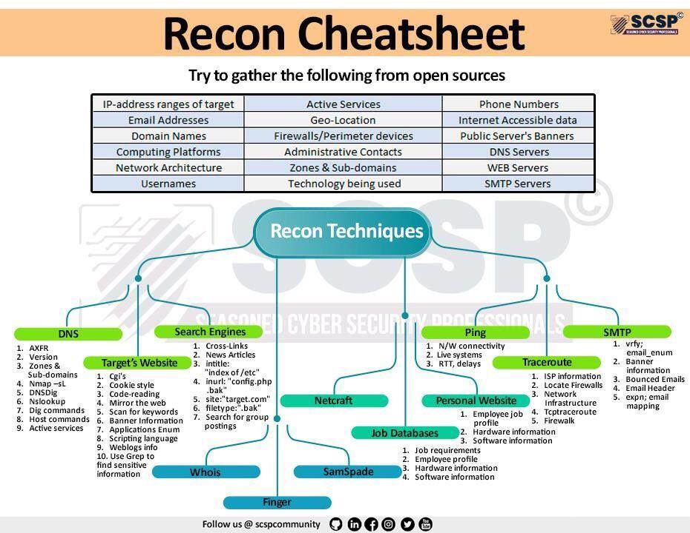
* **Passive Information Gathering** 
  + **Topics**
    - **Domain & registration info**
    - **Dns (passive Info Gathering)**
    - **Website Reconnaissance**
    - **Google Dorks/Hacking**
    - **User information Recon**
    - **Metadata info Gathering**
    - **Firewall Info Gathering**
    - **Recon Through Open-Source Code**
    - **IOT (devices) search websites**
    - **Recon-ng Framework**
    - **Information Gathering Frameworks**
    - **Large Scope Reconnaissance**
    - **Extra Notes**
  + **Domain & registration info** 
    - The first step to take when assessing a website is to gather information about the organization.
      * **Public info such as**
        + The owner name of the domain
        + Ip address or range
        + Technical contacts
        + Expiration date of the domain
      * **Whois**
        + Whois is a TCP service, tool, and a type of database that can provide information about a domain name, such as the name server and registrar. This information is often public since registrars charge a fee for private registration.
        + WHOIS lookups were traditionally done using a command line interface, but a number of simplified web-based tools now exist for looking up domain ownership details from different databases

**Command Line**

Whois [domain]

**Registrar Information**: info on the company that gave the company its domain name such as namecheap , godaddy , ...etc

Domain Name: DDSEC.XYZ

Registry Domain ID: D204548268-CNIC

Registrar WHOIS Server: whois.namecheap.com

Registrar URL: https://namecheap.com

Updated Date: 2020-10-28T21:51:15.0Z

Creation Date: 2020-10-17T11:34:22.0Z

Registry Expiry Date: 2022-10-17T23:59:59.0Z

Registrar: Namecheap

Registrar IANA ID: 1068

……

**Registrant Information**: info on the person who rent the domain name it can be a person or a company ,...etc

Registrant Organization:

Registrant State/Province:

Registrant Country: EG

Name Server:

……. Etc.

……

Registrant Name:

Registrant Email:

Admin Name:

Admin Email:

Tech Name:

Tech Email:

Whois [ip\_addr]

in addition to this standard forward lookup, which gathers information about a DNS name, the whois client can also perform reverse lookups. Assuming we have an IP address, we can perform a reverse lookup to gather more information about it:

**Web Based**

Who.is

Whois.domaintools.com

Whois.com

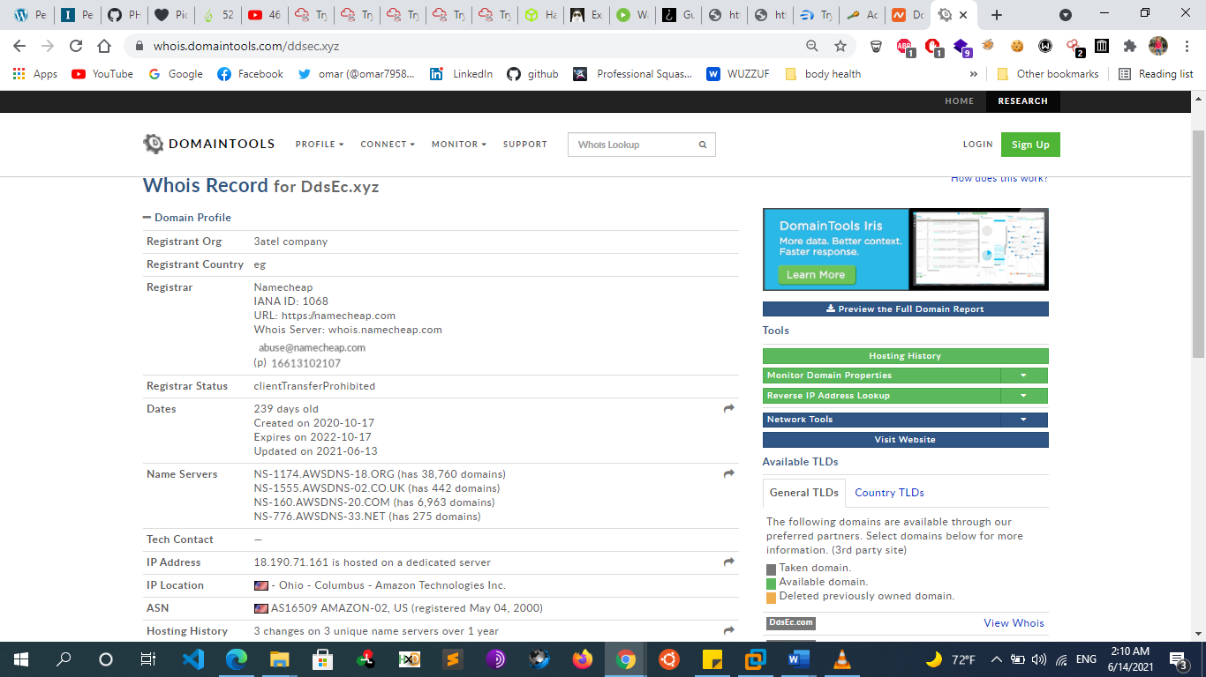

* + - * **Netcraft**
        + Netcraft is an Internet services company based in England offering a free web portal that performs various information gathering functions. The use of services such as those offered by Netcraft is considered a passive technique since we never interact with our target directly.
        + https://News.netcraft.com
        + <https://searchdns.netcraft.com>

For each server found, we can view a “site report” that provides additional information and history about the server by clicking on the file icon next to each site URL

The start of the report covers registration information. However, if we scroll down, we discover various “site technology” entries

* + - * **Lookup.icann.org**
        + 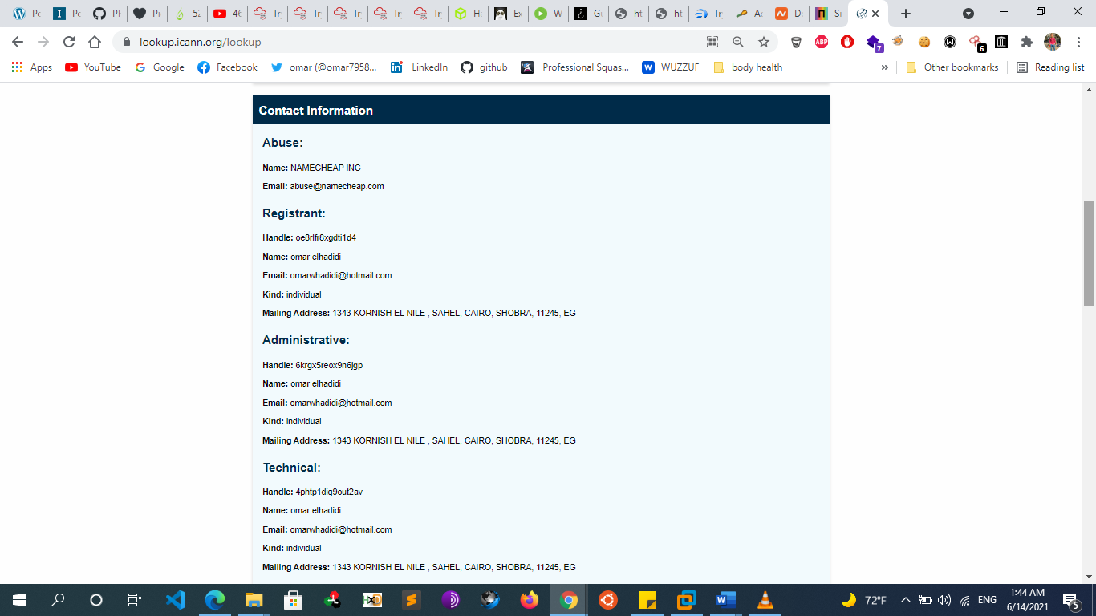
      * 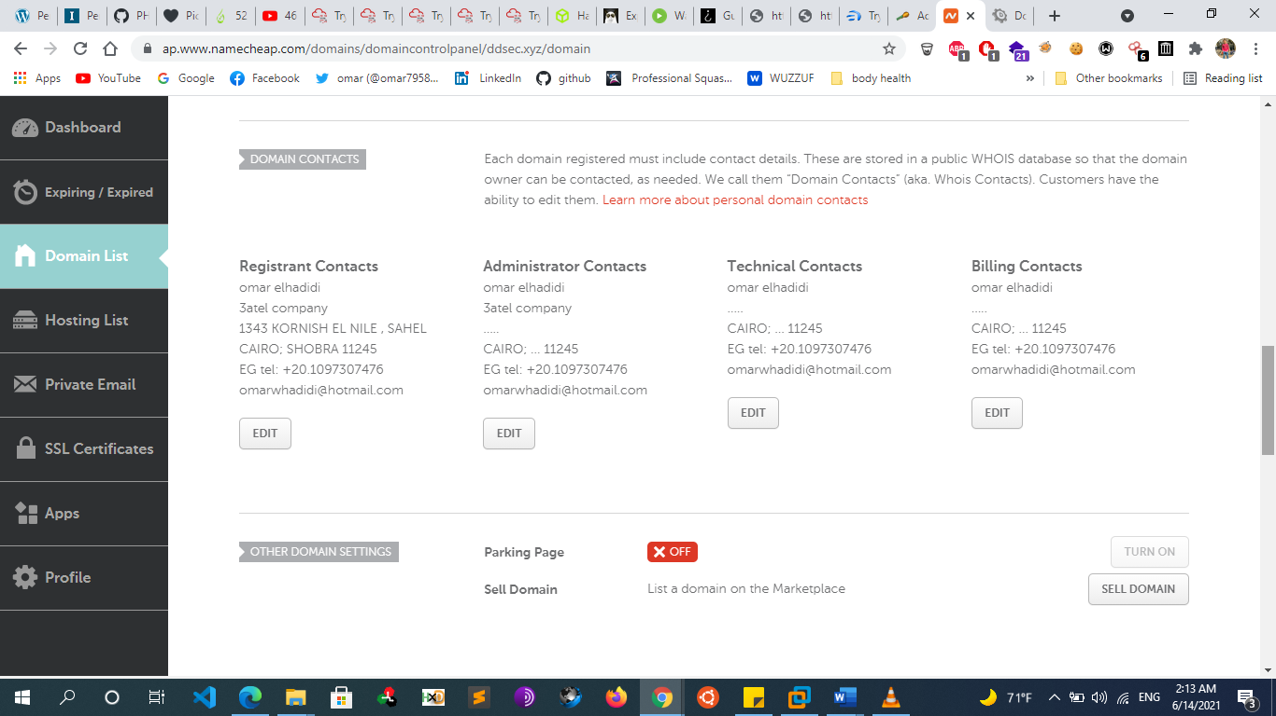
      * **https://viewdns.info/**
        + ViewDNS.info provides a convenient UI for looking up registration information on a target website. ip history , ...Using this information, it may be possible to draw certain conclusions that are not clearly spelled out, such as whether the website is hosted on a shared or dedicated IP address. The answer to this question can imply things about the website's budget as well as traffic
  + **Dns (passive Info Gathering)**
    - Now that we have a bit of valuable information about our target, we can start digging further into the data to start identifying individual targets. A valuable source for such information is the Domain Name System (DNS). We can query it for some of the IP addresses that we received from the WHOIS database.
    - **Dns query websites**
      * Mxtoolbox.com
      * Dnsqueries.com
      * Kloth.net
      * Dnswatch.info
      * Networktools.info
      * Dnsstuff.com
      * Networktools.tom
      * Gsuitetoolbox.com
      * Webmaster-toolkit.com
      * Webbasedtools.com
  + **Website Reconnaissance** 
    - If the client has a website, we can gather basic information by simply browsing the site. Small organizations may only have a single website, while large organizations might have many, including some that are not maintained.
    - **technology used in Websites Info Gathering**
      * **whatweb**
        + whatweb –v [website]
      * **Dmitry**
        + dmitry -winsep [[website]](http://example.com)
        + dmitry -winsepo result.txt [[website]](http://example.com)
      * **Wappalyzer addon**
    - **Archive search & History of the website**
      * website that can help us is archive.org. Here you can simply search a specific domain and then navigate through different date and versions of that specific domain.
      * Similarly, you can use the Google dork cache:URL. With this technique, you will see a cached version of the website.
        + Web.Archive.org
        + Waybackurl script
    - **Firewall Info Gathering**
      * **Wafwoof**
        + Wafwoof –L -> list all waf supported by wafwoof
        + Wafwoof -a [website]
      * **Nmap**
        + nmap -p 80,443 --script=http-waf-detect [website]
    - curl ipinfo.io/193.35.34.6 -> ip info
    - [ipneighbour.com](http://ipneighbour.com/)
      * -> identify if there are multiple websites installed on that host or no
  + **Google Dorks/Hacking**
    - The term “Google Hacking” was popularized by Johnny Long in 2001. Through several talks and an extremely popular book (Google Hacking for Penetration Testers), he outlined how search engines like Google could be used to uncover critical information, vulnerabilities, and misconfigured websites.
    - The “”
      * Say if we wanted to narrow down our search query, we can use quotation marks. Google will interpret everything in between these quotation marks as exact and only return the results of the exact phrase provided...Rather useful to filter through the rubbish that we don't need
    - The **site** operator limits searches to a single domain
    - the, the **filetype** (or ext) operator limits search results to the specified file type.
    - we can use a search for **intitle**:“index of” “parent directory” to find pages that contain “index of” in the title and the words “parent directory” on the page.
      * The output refers to directory listing146 pages that list the file contents of the directories without index pages. Misconfigurations like this can reveal interesting files and sensitive information.
    - We can also modify an operator using **-** to exclude particular items from a search, narrowing the results
      * site:microsoft.com intitle:"index of"
      * site:microsoft.com inurl:phpinfo
      * site:microsoft.com intext:password
      * site:microsoft.com filetype:pdf
      * site:microsoft.com -filetype:pdf
      * site:microsoft.com “specific word”
    - These basic examples only scratch the surface of what we can do with search operators. The Google Hacking Database (GHDB) contains multitudes of creative searches that demonstrate the power of creative searching with combined operators:
  + **User information Recon**
    - **Overview**
      * In addition to gathering information about our target organization’s resources, we can also gather information about the organization’s employees. Our purpose for gathering this information is to
        + compile user or password lists
        + build pretexting for social engineering
        + augment phishing campaigns or client-side attacks
        + execute credential stuffing, and much more.
      * However, the rules of engagement vary for each penetration test. Some penetration tests may be limited to purely technical testing without any social engineering aspects. Other engagements may have few or no restrictions.
    - **Search Engine websites** 
      * Google
      * Bing
      * Yahoo
      * …
    - **Social media Sites**
      * With the help of social media, a penetration tester can easily gather employee’s personal information such as**: phone numbers, addresses, history, CV, opinions, responsibilities, projects and so on.**
      * the previous phase you should have already compiled a list of managers, employees etc. What we have to do now, is gather information on every person on this list.
      * Also, Just about all organizations now maintain some sort of presence on social media. The information a company posts can be very useful for us. We could, for example, use this information to identify potential employees and gain more information about the company and its operations. There are various ways to gather this public information with several tools we have already discussed, such as recon-ng and theHarvester and we can use social media sites such as:
        + Facebook
        + Twitter
        + Instagram
        + Social-searcher.com

search for people in all social media

* + - * **Other Tools**
        + **Twofi** scans a user’s Twitter feed and generates a personalized wordlist used for password attacks against that user. While we will not run any attacks during passive information gathering, we can run this tool against any Twitter accounts we have identified to have a wordlist ready when needed. Twofi requires a valid Twitter API key.
        + **linkedin2username** is a script for generating username lists based on LinkedIn data. It requires valid LinkedIn credentials and depends on a LinkedIn connection to individuals in the target organization. The script will output usernames in several different formats.
        + **Sherlock tool**

Hunt social media account

[**https://github.com/sherlock-project/sherlock.git**](https://github.com/sherlock-project/sherlock.git)

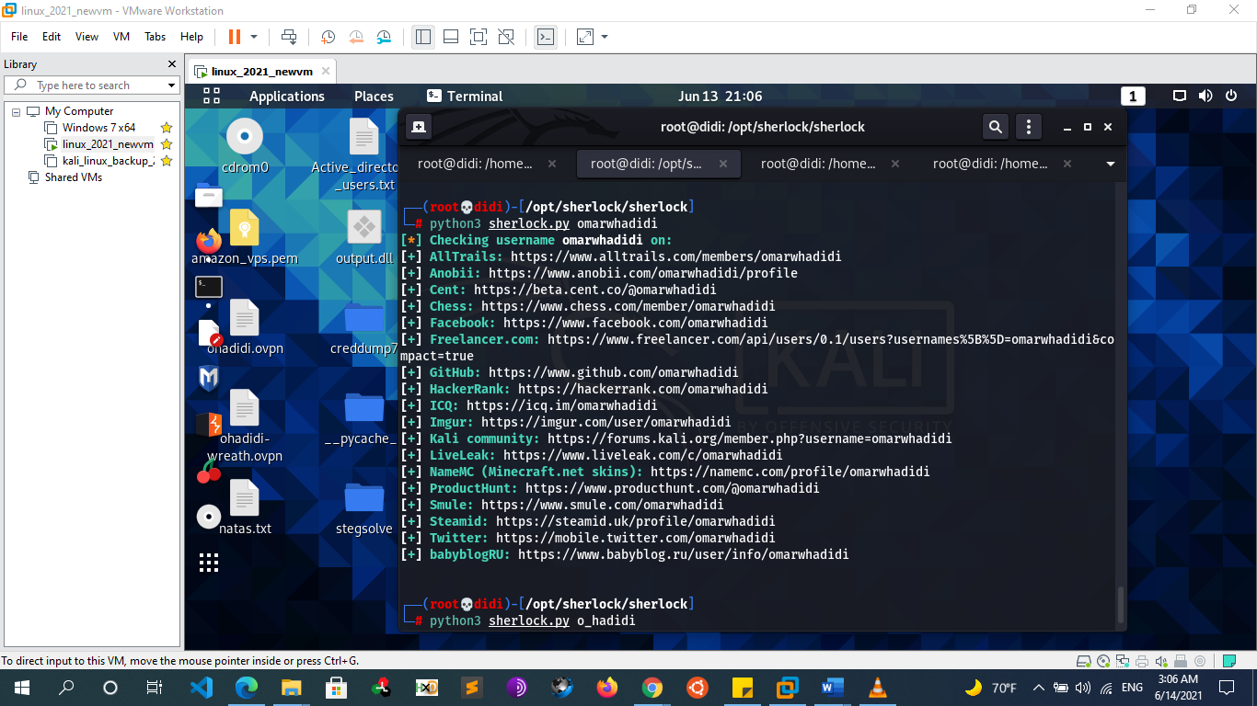

* + - * + **Namechk.com**
      * **At this point of our information gathering phase, we already know some information seen below:**
        + Age
        + Phone Number
        + Business
        + Further searching will tell us:

Email addresses

Addresses

Occupation

Interests

Website Owned

Financial Info

Related documents

* + - **Job search websites**
      * Now we can start looking for job postings and frequenting job boards. Many organizations have a web site section including open positions and career opportunities.
      * This might not seem like harmful information however, an investigator can deduce internal hierarchies, vacancies, projects, responsibilities, weak departments, financed projects, technology implementations and more. If you do not find useful information on the organization website, you can use more specific search engines such as
        + Linkedin
        + Indeed
        + Monster
        + Dice
        + Glacedoor
        + Careerbuilder
        + simplyhired
    - **People Search** 
      * Pipl.com
      * Peoplefinders.com
      * Anywho.com
      * Truecaller.com
      * Peekyou.com
      * Zoominfo.com
      * Peoplelookup.com
      * 123people.com
      * Wink.com
      * Peoplesmart.com
      * Whitepages.com
    - **Email Info Gathering** 
      * **TheHarvester** 
        + Tool that gathers emails, names, subdomains, IPs, and URLs from multiple public data sources.
        + theHarvester -d [website] -l 500 -b {all, baidu, bing, google, linkedin, twitter, virustotal, netcraft, yahoo}
        + theHarvester -d www.psa.com -l 500 -b all

-d to specify the target domain and -b to set the data source to search

* + - * **Metasploit**
        + Use auxiliary/gather/search\_email\_collector
      * **SimplyEmail**
        + git clone https://github.com/killswitch-GUI/SimplyEmail.git
        + ./SimplyEmail.py -all -e TARGET-DOMAIN
    - **Show the email’s password that have been leaked**
      * Haveibeenpwned.com
      * Hacked-emails.com
        + This step can be useful after enumerating emails, we can test if they were pwned or hacked before in any breach and if yes we can go and search for their passwords in that leakage
  + **Metadata info Gathering**
    - **FOCA**
      * As you can imagine, doing this manually can be very tedious and time consuming. A very useful tool that allows us to automatically find and download files is FOCA. By querying search engines like google and bing, Foca is able retrieve files and then attempt to extract metadata such as names, usernames, password, OS etc.
      * Note that this tool works only on Windows unfortunately.
    - **Metagoofil** 
      * **->** download files and metadata about the website
      * metagoofil -d [domain] -t {doc,pdf,xls,ppt,odp,ods,docx,xslx,pptx} -l 200 -n 5 -o [out] -f results.html
    - **exiftool ->** show metada on files
      * apt install exiftool
      * exiftool [file]
  + **Recon Through Open-Source Code**
    - In the following sections, we will discuss various online tools and resources that can be used to passively search for information. One such source of interesting information are open-source projects and online code repositories, such as GitHub GitLab and SourceForge. Code stored online can provide a glimpse into the programming languages and frameworks used by an organization. In some rare occasions, developers have even accidentally committed sensitive data and credentials to public repos.
    - **Github**
      * **Github Dorks**
        + "Company" password
        + "Company" secret
        + "Company" credentials
        + "Company" token
        + "Company" config
        + "Company" key
        + "Company" pass
        + "Company" login
        + "Company" pwd
        + "Company" ssh\_auth\_password
        + "Company" ssh\_user
        + "Company" ssh\_pasword
        + "Company" ftp
        + "Company" security\_credentials
        + "Company" connectionstring
        + "Company" JDBC
        + "Company" send\_key,send\_keys
        + <https://github.com/techgaun/github-dorks/blob/master/github-dorks.txt>
      * **Tools**
        + For larger repos, we can use several tools to help automate some of the searching, such as Gitrob and Gitleaks. Recon-ng also has several modules for searching GitHub. Most of these tools require an access token161 to use the source code hosting provider’s API.
        + Gitrob
        + gitleaks
    - **Security Header Scanner**
      * There are several other specialty websites that we can use to gather information about a website or domain’s security posture. Some of these sites blur the line between passive and active information gathering, but the key point for our purposes is that a third-party is initiating any scans or checks. One such site, Security Headers, 167 will analyze HTTP response headers and provide basic analysis of the target site’s security posture. We can use this to get an idea of an organization’s coding and security practices based on the results.
      * Securityheaders.com
    - **Pastebin.com** 
      * Pastebin is a website for storing and sharing text. The site doesn’t require an account for basic usage. Many people use Pastebin because it is ubiquitous and simple to use. But since Pastebin is a public service, we can use it to search for sensitive information.
      * site for sharing texts can be useful in recon phase
    - **Stackoverflow.com**
      * is a website for developers to ask and answer coding related questions. The site’s value from an information gathering perspective is in looking at the types of questions a given user is asking or answering. If we can reasonably determine a user on Stack Overflow is also an employee of our target organization, we may be able to infer some things about the organization based on the employee’s questions and answers.
      * For example, if we found a user that is always asking and answering questions about Python, it would be reasonable to assume they use that programming language on a daily basis, and it would likely be used at the organization where they are employed.
      * Even worse, if we find employees discussing sensitive information such as vulnerability remediation on these types of forums, we could discover unpatched vulnerabilities during this phase.
    - **SSL Server Test**
      * Another scanning tool we can use is the SSL Server Test from Qualys SSL Labs.171 This tool analyzes a server’s SSL/TLS configuration and compares it against current best practices. It will also identify some SSL/TLS related vulnerabilities, such as Poodle or Heartbleed
      * https://www.ssllabs.com/ssltest/
  + **IOT (devices) search websites** 
    - **Shodan.io**
      * **Overview**
        + As we gather information on our target, it is important to remember that traditional websites are just one part of the Internet. Shodan is a search engine that **crawls devices connected to the Internet including but not limited to the World Wide Web**. This includes the servers that run websites but also devices like routers and IoT devices.
        + **Google and other search engines look for web server content, while Shodan searches for Internet-connected devices**, interacts with them, and displays information about them. And banners. and indexes the services run on each IP address
        + Shodan searches includes the following protocols

RDP

FTP

Telnet

HTTP(S)

SSH

SNMP

MySQL / MondoDB

and few more

So we can use it to search for devices with default username and password, viewing the configuration of a device, detect server versions, and much more.

* + - * **Example**
        + Let’s say we are performing a pentest on a company, and we want to find out what services one of their servers run. We need to grab their IP address. first

We can do this using ping

We can ping tryhackme.com and the ping response will tell us their IP address.

* + - * + Then once we do this, we put the IP address into Shodan to get:
        + 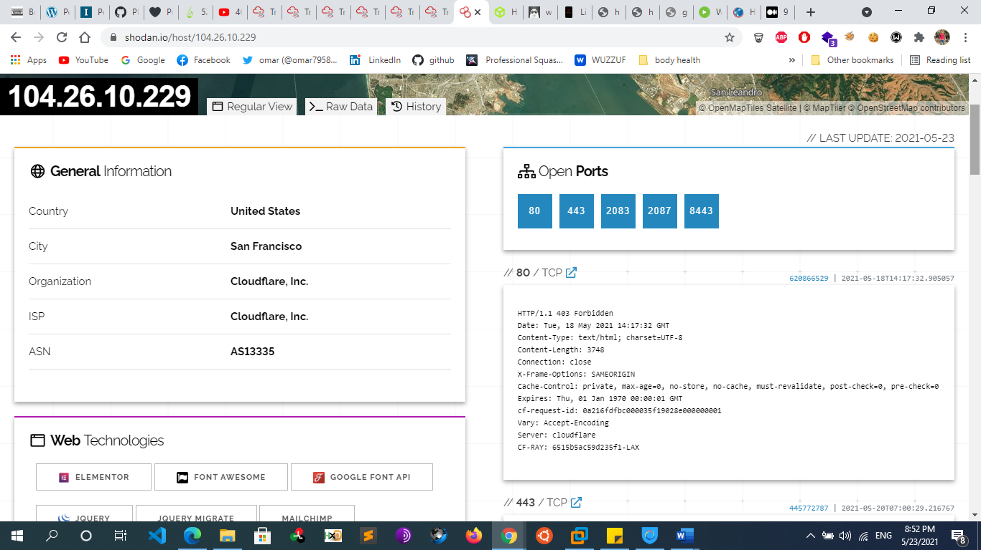
        + We can see that TryHackMe runs on Cloudflare in the United States and they have many ports open. Cloudflare acts as a proxy between TryHackMe and their real servers. If we were pentesting a large company, this isn’t helpful. We need some way to get their IP addresses.
        + We can do this using **Autonomous System Numbers**.

An autonomous system number (ASN) is a global identifier of a range of IP addresses. If you are an enormous company like Google, you will likely have your own ASN for all of the IP addresses you own.

We can put the IP address into an ASN lookup tool such as <https://www.ultratools.com/tools/asnInfo> ,

Which tells us they have the ASN AS14061.

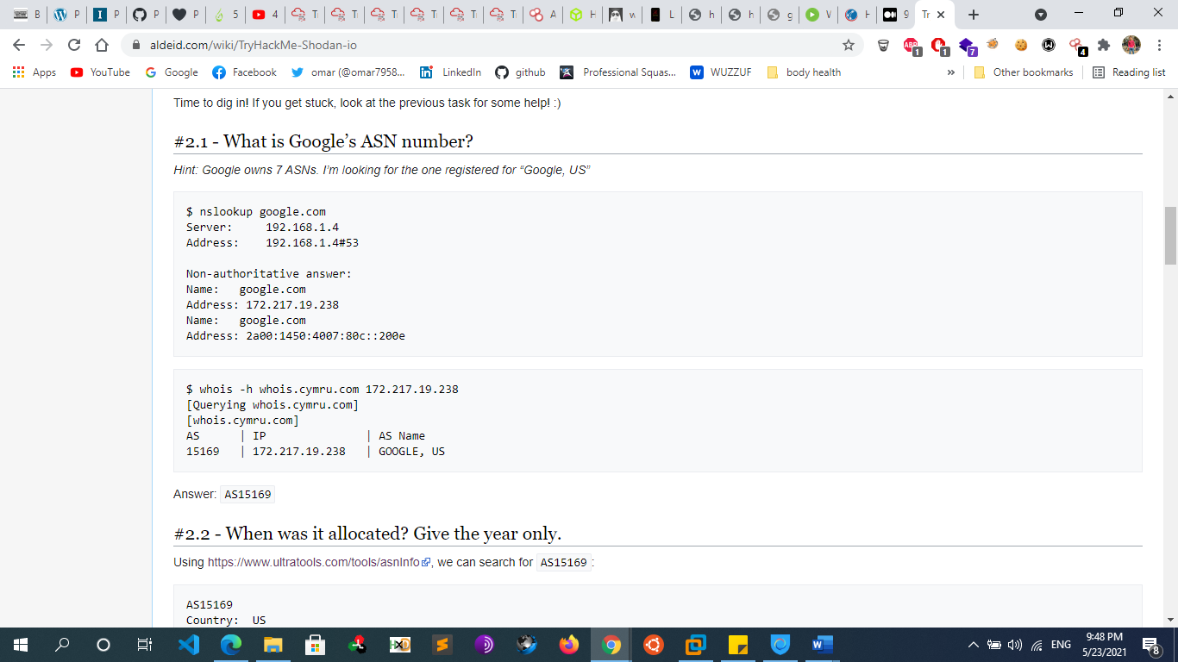

* + - * + 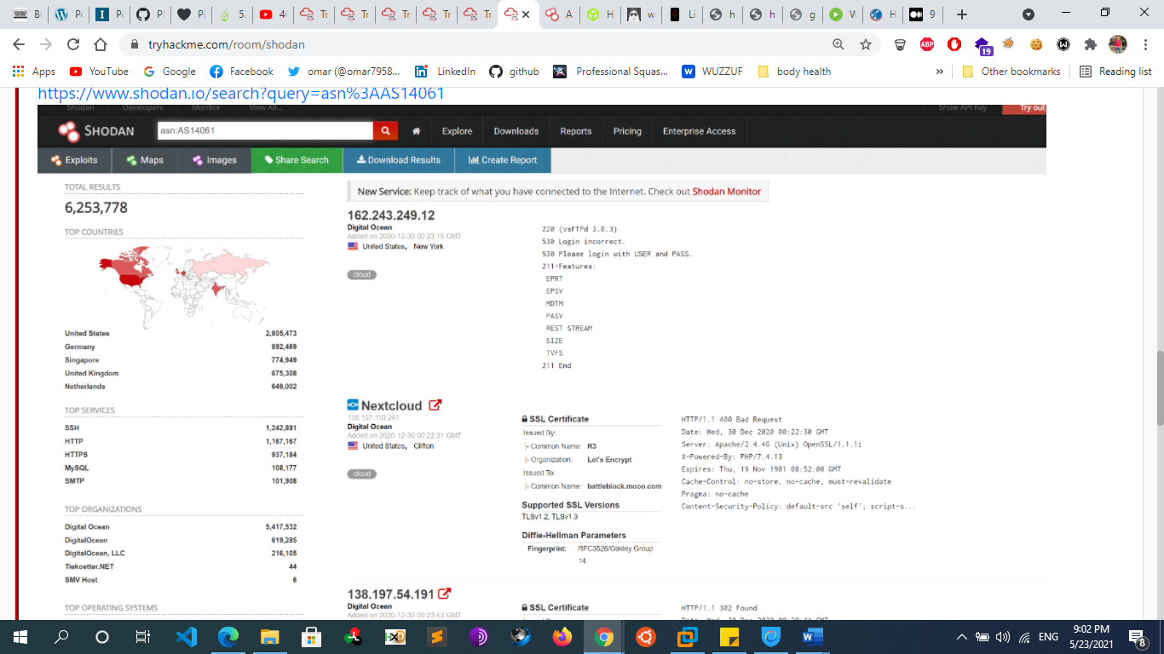
        + On Shodan.io, we can search using the ASN filter. The filter is **ASN:[number]** where number is the number we got from earlier, which is AS14061. Doing this, we can see a whole range 6.2 million websites, in fact) that are on this one single ASN!
        + Knowing the ASN is helpful, because we can search Shodan for things such as coffee makers or vulnerable computers within our ASN, which we know (if we are a large company) is on our network.
      * **Shodan Filters**
        + Here are some nice filters we can use on Shodan:

City

Country

Geo (coordinates)

Hostname: filters results for hosts that contain the value in their hostname

net (based on IP / CIDR)

os (find operating systems)

port

Vuln:[vuln\_name]

let’s us search for IP addresses vulnerable to an exploit. Let’s say we want to find IP addresses vulnerable to Eternal Blue: **Vuln: ms17-010**

CVE search is only allowed to academic or business subscribers

product: [name]

product:MySQL

ASN:[number]

Search ip address for that ASN

[before/after] day/month/year: search only for data that was collected before or after the given date

Server: SQ-WEBCAM

Find webcams

* + - * + Let now see some search examples. Suppose we want to find all the devices running apache and that are in Italy (IT) our search query is :

apache country:IT

* + - * + Shodan has some lovely webpages with Dorks that allow us to find things. Their search example webpages feature some.

**has\_screenshot:true encrypted attention**

Which uses optical character recognition and remote desktop to find machines compromised by ransomware on the internet.

**vuln:CVE-2014-0160**

Internet connected machines vulenrable to heartbleed.

**http.favicon.hash:-1776962843**

Solar Winds Supply Chain Attack by using Favicons:

You can find more Shodan Dorks on GitHub.

* + - * **Shodan API**
        + Shodan.io has an API! It requires an account
        + The API lets us programmatically search Shodan and receive a list of IP addresses in return. If we are a company, we can write a script to check over our IP addresses to see if any of them are vulnerable
      * **Shodan Extension** 
        + Shodan also has an extension.

<https://chrome.google.com/webstore/detail/shodan/jjalcfnidlmpjhdfepjhjbhnhkbgleap>

* + - * + When installed, you can click on it and it’ll tell you the IP address of the webserver running, what ports are open, where it’s based and if it has any security issues.
        + I imagine this is a good extension for any people interested in bug bounties, being quickly able to tell if a system looks vulnerable or not based on the Shodan output.
      * **Shodan Monitor**
        + Shodan Monitor is an application for monitoring your devices in your own network. In their words:
        + Keep track of the devices that you have exposed to the Internet. Setup notifications, launch scans and gain complete visibility into what you have connected.Previously we had to do this using their API, but now we have this fancy application.Access the dashboard via this link:

<https://monitor.shodan.io/dashboard>

* + - **Censys.com**
  + **Recon-ng Framework**
    - recon-ng is a module-based framework for web-based information gathering. Recon-ng displays the results of a module to the terminal but it also stores them in a database. Much of the power of recon-ng lies in feeding the results of one module into another, allowing us to quickly expand the scope of our information gathering.
    - **commands**
      * recon-ng
        + start the framework
        + According to the output, we have no modules installed to use recon-ng. We can add modules from the recon-ng “Marketplace”.
      * help
      * marketplace search [module name]
        + We’ll search the marketplace from the main prompt with marketplace search, providing a search string as an argument.
        + Notice that some of the modules are marked with an asterisk in the “K” column. These modules require credentials or API keys
      * marketplace info [module name]
        + We can learn more about a module by using marketplace info followed by the module name.
      * marketplace install all
        + ->install all the modules on my pc
      * marketplace install [module name]
      * After installing the module, we can load it with module load followed by its name. Then, we’ll use info to display details about the module and required parameters
        + modules search

- > list all modules

* + - * + modules load [module name]

-> same as use module

Ex  : modules load recon/profiles-profiles/profiler

* + - * + info

 -> list module info and options

* + - * + options set [option] [value]

If we use the “default” value, recon-ng will look up the information in its database

* + - * + run

run the module

* + - * + back

return to the main recon-ng prompt and try the

command again

* + - * + show [double tab]

->to show all we can show

* + - * + Show hosts

view stored data

* + - * + show profiles

-> show all profiles resulted from scan

* + **Information Gathering Frameworks**
    - **OSINT Framework**
      * the OSINT Framework includes information gathering tools and websites in one central location. Some tools listed in the framework cover more disciplines than information security. The OSINT framework is not meant to be a checklist, but reviewing the categories and available tools may spur ideas for additional information gathering opportunities
      * <https://osintframework.com/>
      * 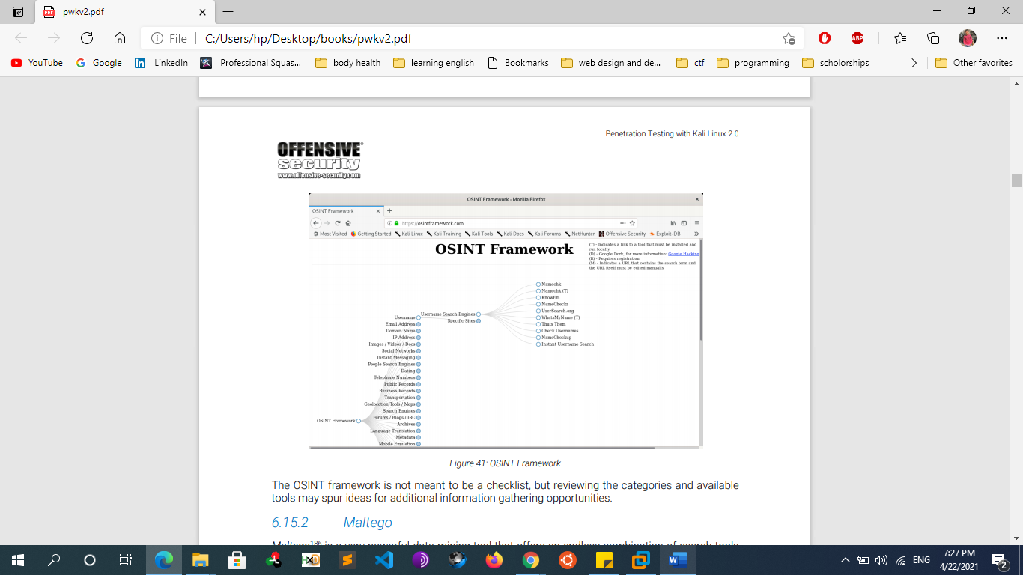
    - **Maltego** 
      * Maltego is a very powerful Gui data mining tool that offers an endless combination of search tools and strategies.
      * Maltego searches thousands of online data sources, and uses extremely clever “transforms” to convert one piece of information into another
      * gather domain owner info , Emails  , domains , ...
  + **Large Scope Reconnaissance** 
    - **Autonomous system number (ASN) Recon**
      * **What is ASN**
        + An Autonomous System (AS) is a set of Internet routable IP prefixes belonging to a network or a collection of networks that are all managed, controlled and supervised by a single entity or organization. An AS utilizes a common routing policy controlled by the entity. The AS is assigned a globally unique 16 digit identification number一known as the autonomous system number or ASN一by the Internet Assigned Numbers Authority (IANA).
        + Autonomous System Number (ASN) is a globally unique identifier that defines a group of one or more IP prefixes run by one or more network operators that maintain a single, clearly-defined routing policy. These groups of IP prefixes are known as autonomous systems.
        + Autonomous systems numbered one to 64511 are available by IANA for global use. The 64512 to 65535 series is reserved for private and reserved purposes. Autonomous Systems were introduced to regulate networking organizations such as Internet Service Providers (ISP), educational institutions and government agencies.
        + Border Gateway Protocol (BGP) is the protocol that manages the routed peerings, prefix advertisement and routing of packets between different autonomous systems across the Internet. BGP uses the ASN to uniquely identify each system. In effect, BGP is the routing protocol for AS paths across the Internet.
      * **Tools**
    - **Company acquisitions**
  + **Extra Notes**
    - **Image Geolocation [IMINT/GEOINT]**
      * **Overview**
        + **IMINT/GEOINT**, which is short for Image intelligence and geospatial intelligence.
      * **Step 1: [your eye]**
        + **Let's introduce you to your first tool - your eyes!**  
          Before we can apply a tool or a methodology for finding the location of an image, **we should use our eyes to scan the image for important information**. Extracting key data points from the image will allow you to apply the right tool, craft a good Google search or identify which part of the world the image might have been taken in.
        + There are 5 elements of IMINT that you should consider when looking at an image, according to Geoint expert [Benjamin Strick](https://twitter.com/BenDoBrown):

- Context  
- Foreground  
- Background  
- Map markings  
- Trial and error

* + - * + A geolocation challenge like this lacks one important factor, which is the context or the source of the image. In real-world cases, you usually have a context in which the image was produced or shared, usually called context clues. Most of these challenges will not have context clues but you may find clues in the titles and descriptions, or if you're stuck you can use the hint function.
        + **Here are some questions you should ask yourself while analysing:**

Are there any obvious data in the image that reveals the location, like a street name or storefront signs?

Can you determine the country or region of the image by, for instance, which side of the road they drive on, language or architectural characteristics that may reveal a country or continent/region?

Do you recognize road sign styles, nature and environmental characteristics, or popular motor vehicle brands or vehicle types?

What is the quality of any visible infrastructure like? Is the road paved or do you see gravel roads?

Do you see any unique landmarks, buildings, bridges, statues or mountains that can help you geolocate the image?

One of the more obvious ways we can geolocate an image is to look at the image details. Does it contain EXIF data?

* + - * **Step 2: google**
        + your first tool, Google! If you see anything in the image that can be extracted into a keyword, phrase, a company name, telephone number or any other question you may have as a result of scanning the image up and down: GOOGLE IT!
      * **Step 3: image reverse search programs**
        + One of the methods for geolocating an image is to do an image reverse search. This means that we are searching for the image itself online, and if the image has been indexed by search engines, we may find the exact image or we can do a visual search or crop search to help us find similar images.
        + I recommend adding this extension to ease the workflow for when you find images online that you want to do an image reverse on:

**Addon description:** "Perform a search by image. Choose between the image search engines **Google, Bing, Yandex, TinEye and Baidu**."

**Chrome:** [RevEye Reverse Image Search](https://chrome.google.com/webstore/search/RevEye%20Reverse%20Image%20Search?hl=no" \t "_blank)-

**Firefox:**[RevEye Reverse Image Search](https://addons.mozilla.org/nb-NO/firefox/addon/reveye-ris/" \t "_blank)

* + - * + **Yandex reverse image**

Use Yandex first, and then a hundred more times. Then after Yandex, use Bing. Then Google

Yandex will usually provide the best results. However, there is never a guarantee for this, so you should always try multiple search engines if one comes up empty handed

Another neat feature of the Yandex RIS, is that images with text in them are automatically OCRed, meaning that the text is extracted and turned into something machine readable. Of course, this all depends on the image quality and most importantly the text alignment in the image. If it’s written in a straight line, chances are high Yandex can OCR it. Crooked or handwritten text might not work.

* + - * + **Bing reverse image**

Within an image search, Bing allows you to crop a photograph (button below the source image) to focus on a specific element in said photograph, as seen below. The results with the cropped image will exclude the extraneous elements, focusing on the user-defined box.

* + - * + **Google reverse image**

Google will automatically associate a keyword with the picture. Changing this keyword manually will alter the results. In some cases, you might want to try different keywords to get better overall results

* + - * + Remember that changing the crop and the keywords for searching an image may yield completely different results.

**Cropping pictures Improve search results**

* + - * **Step 4: Google maps**
        + When geolocating an image, we want to point out big landmarks we can easily find on a map. Road layouts, business names,
      * **Notes**
        + Geolocating videos aren't much different from geolocating images. A video is just a string of images, usually played at 24 frames(or images) per second. In other words, a video will hold a whole lot more images that can be analyzed, reversed and scrutinized by you.

FFmpeg, which will help you extract the key images from the video

* + - * + It's important to know what is and isn't likely to be in a country. For example, it is unlikely for a regular Catholic church to appear in places where Budhism / islam is the most popular religion.
        + The language used on the shops and vehicles matter too. We can use Google translate to predict what language it could be.
        + Which side of the road the cars are on, the license plates (you normally can find out what country or state the license plate is from), the markings on the road (different countries have different markings), the style of traffic lights, the clothing choices of those walking around.
        + To be good at geolocation, we've got to open our eyes to all that could be. In your country, for example, it may be common to wear coats during the winter periods. However, in other countries it may not be (think Australia).
        + Even the smallest of things that we wouldn't normally think twice about can reveal to us the possible location.
        + One of the more obvious ways we can geolocate an image is to look at the image details. Does it contain EXIF data?
        + What about where it was posted - is there a location tagged on social media?
      * **Resources**
        + https://www.bellingcat.com/resources/how-tos/2019/12/26/guide-to-using-reverse-image-search-for-investigations/
    - **To Host a website there are 2 important steps:**
      * Rent a Domain From any website like Godaddy ,domain.com , namecheap
      * Rent a server/vps or shared hosting to put the website file on it
    - **Target location info gathering**
      * Maps.google.com
      * Google.com/earth
    - **Download websites (mirror)**
      * HTTRACK
      * Wget [website]
      * Surfoffline.com
      * Calluna-software.com
    - **Taking Notes**
      * An information gathering campaign can generate a lot of data, and it’s important that we manage that data well so that we can leverage it in further searches or use it in a later phase. There is no right or wrong way to take notes. However, we may find it easier to retrieve information later on if we keep detailed and well formatted notes.
      * Take Notes for everything you gather you can use MindMaps
    - **Crunchbase/inc**
      * Info about organizations
      * CrunchBase is a database where you can find information about:
        + Companies
        + People
        + Investors and financial information
      * The power of CrunchBase is grounded on the concept of anyone being able to edit information in it.
      * Another useful online resource is [www.inc.com](http://www.inc.com). Inc. focuses its attention on growing companies and provides advice, resources and information to companies. Moreover, Inc. offers a list of the 500/5000 fastest-growing private companies, showing very useful information and statistics on them
    - **Search in Trello site**
      * Ex: site:Trello intext:domain intext:password
* **SCANNING (Active Reconnaissance)** 
  + **Topics**
    - **Network Tracing:**
    - **Network Discover:**
    - **Port scanning:**
    - **Service/Version Scanning:**
    - **OS Fingerprinting**
    - **Vulnerability Scanning**
    - **Dns Scanning & Enumeration**
    - **Web application Enumeration**
  + **Network Tracing:** 
    - determine the network topology and draw a map
  + **Network Discover:** 
    - **Overview**
      * (ping sweep) identify live hosts on a network
      * To deal with large volumes of hosts, or to otherwise try to conserve network traffic, we can attempt to probe targets using Network Sweeping techniques, in which we begin with broad scans, and use more specific scans against hosts of interest.
    - **Manually with ping**
      * Ping [ip address]
    - **Netdiscover**
      * Netdiscover –I eth0 –r 192.168.1.0/24
    - **Nmap**
      * Nmap –sn –n 192.168.1.0/24
    - **Ping , traceroute , tracert**
  + **Port scanning:**
    - **Overview**
      * Port scanning is the process of inspecting TCP or UDP ports on a remote machine with the intention of detecting what services are running on the target and what potential attack vectors may exist
    - **Port scanner tools**
      * **Netcat**
        + Necat main purpose is not a port scanning tool but can be used for learning purpose
        + nc -nvv -w 1 -z 10.11.1.220 3388-3390

The -w option specifies the connection timeout in seconds and -z is used to specify zero-I/O mode, which will send no data and is used for scanning:

-u : udp scan

* + - * **Hping , fping**
      * **Nmap / zenmap**
        + Nmap most modules require root privilege
      * **Unicorn scan**
        + unicornscan -H -msf -Iv 192.168.56.101 -p 1-65535
        + unicornscan -H -mU -Iv 192.168.56.101 -p 1-65535
        + Arguments :

-H resolve hostnames during the reporting phase

-m scan mode (sf - tcp, U - udp)

-Iv - verbose

* + - * **Masscan**
      * **Solarwinds port Scanner**
    - **Port Scanning Techniques** 
      * **Full Tcp Scan (connect scan)** 
        + Default technique if not root user
        + perform the three-way handshake
        + 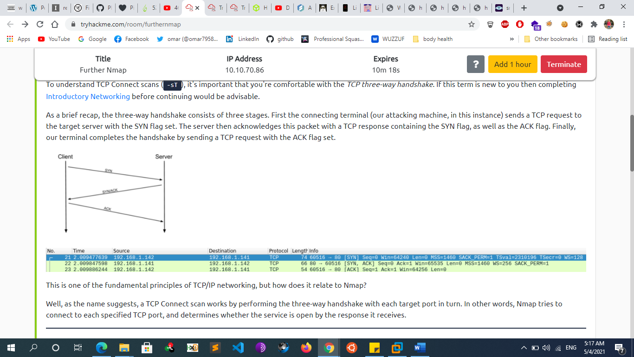
        + In other words, if Nmap sends a TCP request with the SYN flag set to a **closed** port, the target server will respond with a TCP packet with the RST (Reset) flag set. By this response, Nmap can establish that the port is closed.
      * **Stealth Scan** 
        + Doesn’t complete the three-way handshake
        + Please note that term “stealth” refers to the fact that, in the past, primitive firewalls would fail to log incomplete TCP connections. This is no longer the case with modern firewalls and even if the stealth moniker has stuck around, it could be misleading.
        + **Syn scan (half open scan)**

Default technique if root user

SYN scanning is a TCP port scanning method that involves sending SYN packets to various ports on a target machine without completing a TCP handshake. If a TCP port is open, a SYN-ACK should be sent back from the target machine, informing us that the port is open. At this point, the port scanner does not bother to send the final ACK to complete the three-way handshake

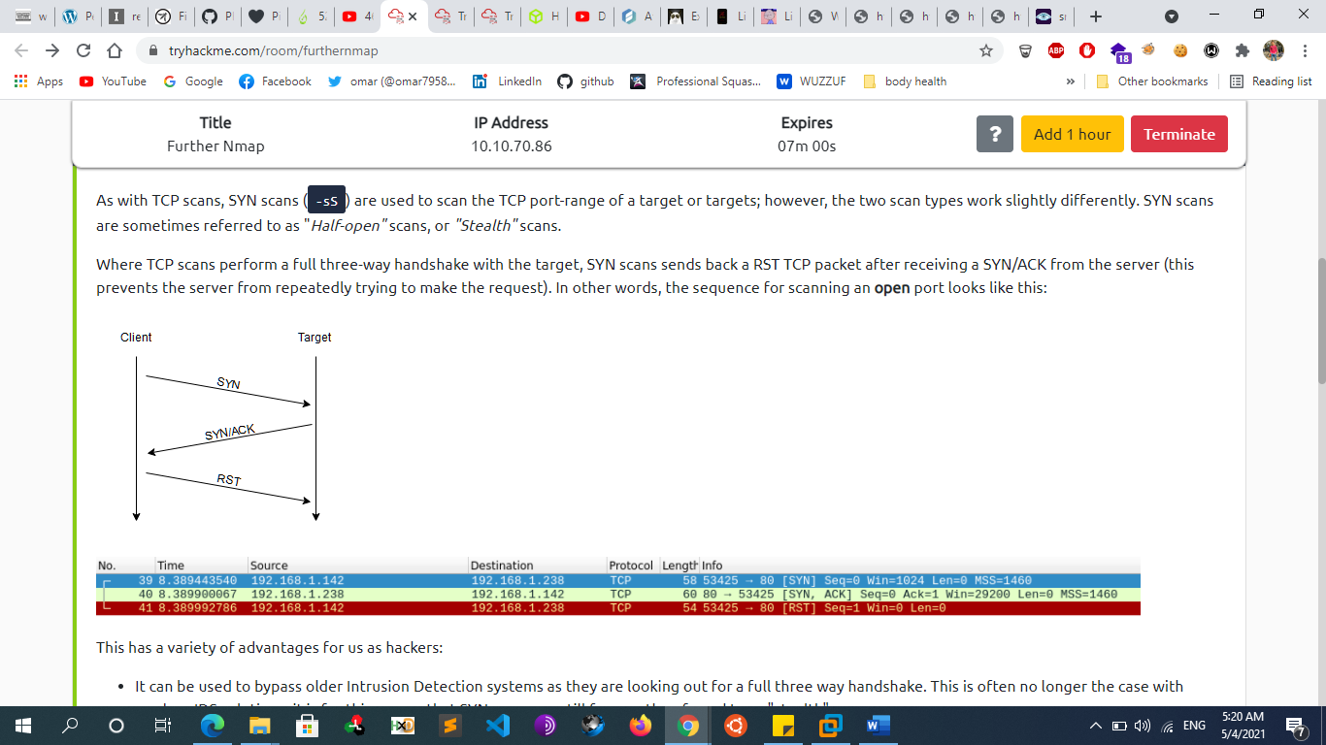



This has a variety of advantages for us as hackers:

It can be used to bypass older Intrusion Detection systems as they are looking out for a full three-way handshake. This is often no longer the case with modern IDS solutions; it is for this reason that SYN scans are still frequently referred to as "stealth" scans.

SYN scans are often not logged by applications listening on open ports, as standard practice is to log a connection once it's been fully established. Again, this plays into the idea of SYN scans being stealthy.

Without having to bother about completing (and disconnecting from) a three-way handshake for every port, SYN scans are significantly faster than a standard TCP Connect scan.

* + - * + **Null Scan**

As the name suggests, NULL scans (-sN) are when the TCP request is sent with no flags set at all. As per the RFC, the target host should respond with a RST if the port is closed

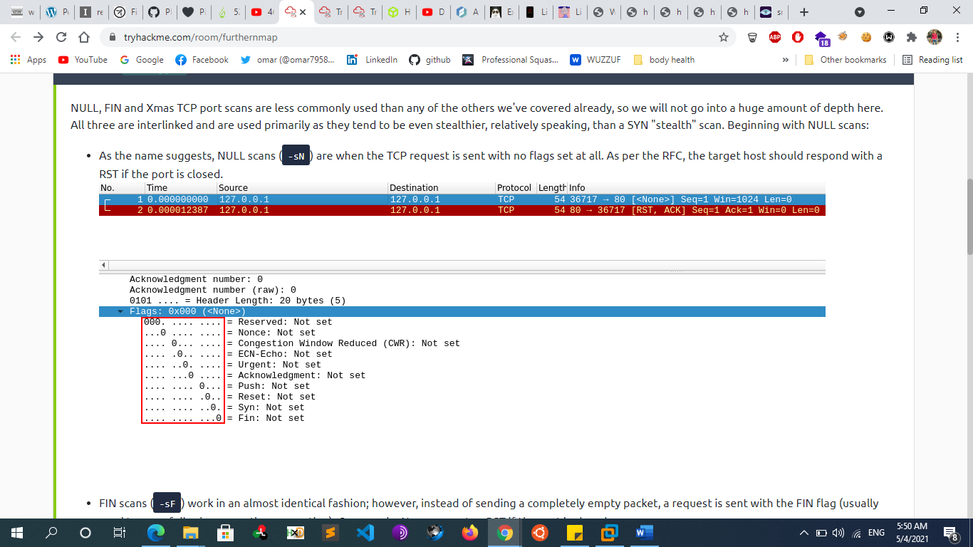



* + - * + **Fin Scan**

FIN scans (-sF) work in an almost identical fashion; however, instead of sending a completely empty packet, a request is sent with the FIN flag (usually used to gracefully close an active connection). Once again, Nmap expects a RST if the port is closed.

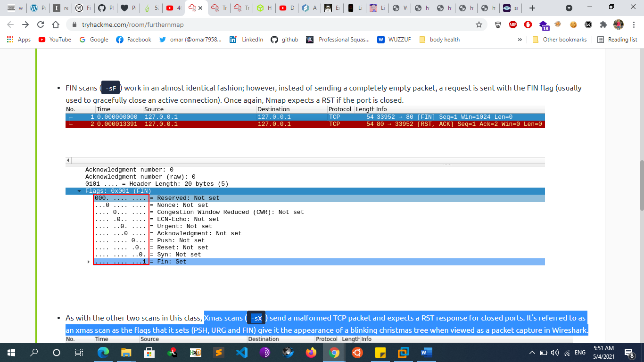



* + - * + **Xmas scan**

Xmas scans (-sX) send a malformed TCP packet and expects a RST response for closed ports. It's referred to as an xmas scan as the flags that it sets (PSH, URG and FIN) give it the appearance of a blinking Christmas tree when viewed as a packet capture in Wireshark.

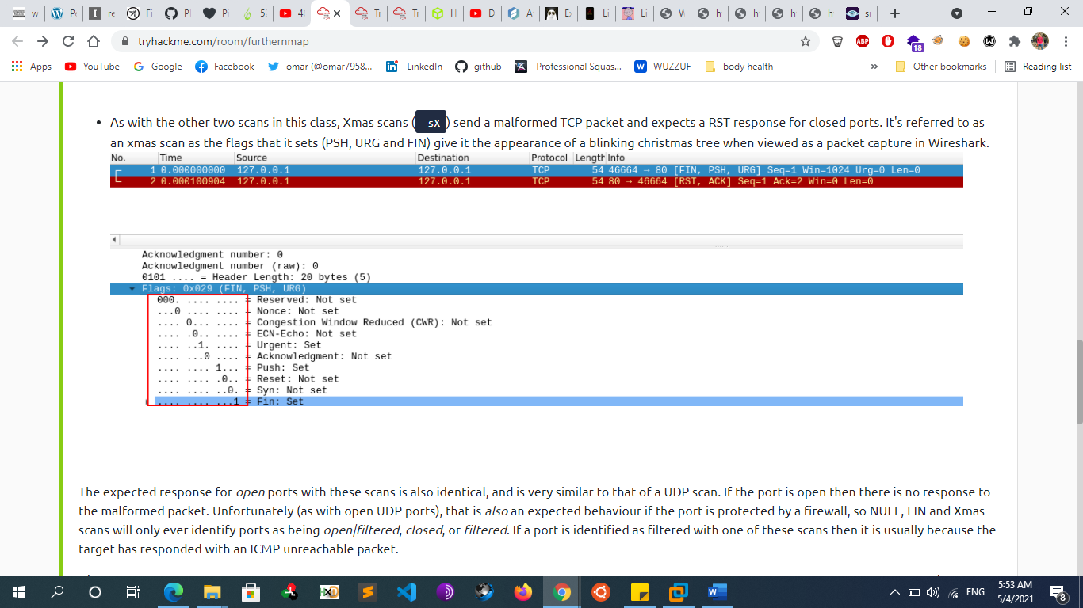



* + - * **Ack Scan**
      * **Mainmon Scan**
      * **Idle Scan**
      * **Udp Scan**
        + When a packet is sent to an open UDP port, there should be no response. When this happens, Nmap refers to the port as being open|filtered. In other words, it suspects that the port is open, but it could be firewalled. If it gets a UDP response (which is very unusual), then the port is marked as open. More commonly there is no response, in which case the request is sent a second time as a double-check. If there is still no response then the port is marked open|filtered and Nmap moves on.
        + When performing a UDP scan, Nmap will use a combination of two different methods to determine if a port is open or closed. For most ports, it will use the standard “ICMP port unreachable” method described earlier by sending an empty packet to a given port. However, for common ports, such as port 161, which is used by SNMP, it will send a protocol-specific SNMP packet in an attempt to get a response from an application bound to that port.
  + **Service/Version Scanning:** 
    - We can also identify services running on specific ports by inspecting service banners and determine the version of services and protocols
    - Nmap –sV [ip address]
  + **OS Fingerprinting**
    - attempts to guess the target’s operating system and This is possible because operating systems often have slightly different implementations of the TCP/IP stack (such as varying default TTL values and TCP window sizes) and these slight variances create a fingerprint that tools can often identify.
    - Note that OS Fingerprinting is not always 100% accurate, but a best-guess attempt
    - **Passive Fingerprinting:**
      * attempts to guess the target’s operating system without interaction with him (sniffing)
        + **Pof**
        + **Satori**
        + **Network minor**
    - **Active Fingerprinting:**
      * attempts to guess the target’s operating system by inspecting returned packets by interacting with him
      * **Banner grabbing**
        + Nc [ip] [port]
        + Ncat [ip] [port]
        + telnet [ip] [port]
      * **nmap** 
        + nmap –O [ip address]
      * **xprobe2** 
        + xprobe2 -v -p tcp:80:open [IP]
  + **Vulnerability Scanning**
    - **Some comparison** 
      * **Manual scanning vs automated scanning**
      * **Internal scanning vs internet scanning**
      * **Authenticated scanning vs unauthenticated scanning**
        + Most scanners can be configured to run authenticated scans, in which the scanner logs in to the target with a set of valid credentials. In most instances, authenticated scans use a privileged user account in order to have the best visibility into the target system. To run an authenticated scan against a Linux target, we simply enable the SSH service on the Linux target and configure the scanner with valid user credentials. Most scanners will use this access to review package versions and validate configurations in an attempt to discover potential vulnerabilities
        + Authenticated scans generate a wealth of additional information and produce more accurate results at the expense of a longer scan time. Although an authenticated scan can be used during a penetration test (using discovered credentials, for example), it is more commonly used during the patch management process.
    - **Network Vulnerability Scanners**
      * **How Vulnerability Scanners Work**
        + Vulnerability scanner implementations vary, but generally follow a standard workflow. Most automated scanners will:

1. Detect if a target is up and running.

2. Conduct a full or partial port scan, depending on the configuration.

3. Identify the operating system using common fingerprinting techniques.

4. Attempt to identify running services with common techniques such as banner grabbing, service behavior identification, or file discovery.

5. Execute a signature-matching process to discover vulnerabilities.

* + - * **Nessus**
        + manually download the 64-bit .deb file for Kali from the Tenable website:

https://www.tenable.com/downloads/nessus

* + - * + Install Nessus

dpkg -i Nessus-6.9.4-debian6\_amd64.deb

or sudo apt install ./Nessus-X.X.X.deb

* + - * + start the service

/etc/init.d/nessusd start

* + - * + Launch nessus

<https://localhost:8834/>

* + - * + Nessus supports a number of scan types, including:

Basic Network Scan: Generic scan with various checks that are suitable to be used against various target types.

Credentialed Patch Audit: **Authenticated scan** that enumerates missing patches.

Web Application Tests: Specialized scan for discovering published vulnerabilities in Web Applications.

Spectre and Meltdown: Targeted scan for the Spectre231 and Meltdown232 vulnerabilities.

* + - * **Openvas**
        + Apt install openvas
        + Openvas-setup
        + http://localhost:9392
      * **Nexpose**
      * **Acunetix**
      * **Netsparker**
      * **NMAP (NSE)**
        + NSE scripts are located in the /usr/share/nmap/scripts directory.
        + Nmap <ip> --script vuln
    - **Web Vulnerability Scanners**
      * **Nikto**
        + Nikto is a highly configurable Open-Source web server scanner that tests for thousands of dangerous files and programs, vulnerable server versions and various server configuration issues. It performs well, but is not designed for stealth as it will send many requests and embed information about itself in the User-Agent header.

Nikto –h [site]

Basic scanning This scan type will retrieve the headers advertised by the webserver or application (I.e. Apache2, Apache Tomcat, Jenkins or JBoss) and will look for any sensitive files or directories (i.e. login.php, /admin/, etc)

Nikto -h [site] --maxtime=30s

-> limit the scan time because it takes a lot of time

nikto -h http://ip\_address -o report.html

save result in html report

* + - * + **Introduction to Plugins**

Plugins further extend the capabilities of Nikto. Using information gathered from our basic scans, we can pick and choose plugins that are appropriate to our target. You can use the **--list-plugins** flag with Nikto to list the plugins

nikto -h 10.10.10.1 -Plugin [plugin\_name]

apacheusers Attempt to enumerate Apache HTTP Authentication Users

cgi Look for CGI scripts that we may be able to exploit

robots Analyse the robots.txt file which dictates what files/folders we are able to navigate to

dir\_traversal Attempt to use a directory traversal attack (i.e. LFI) to look for system files such as /etc/passwd on Linux

* + - * + **Tuning Your Scan for Vulnerability Searching**

Nikto has several categories of vulnerabilities that we can specify our scan to enumerate and test for. The following list is not extensive and only include the ones that you may commonly use

Nikto -tuning [value] [website]

* + - * + 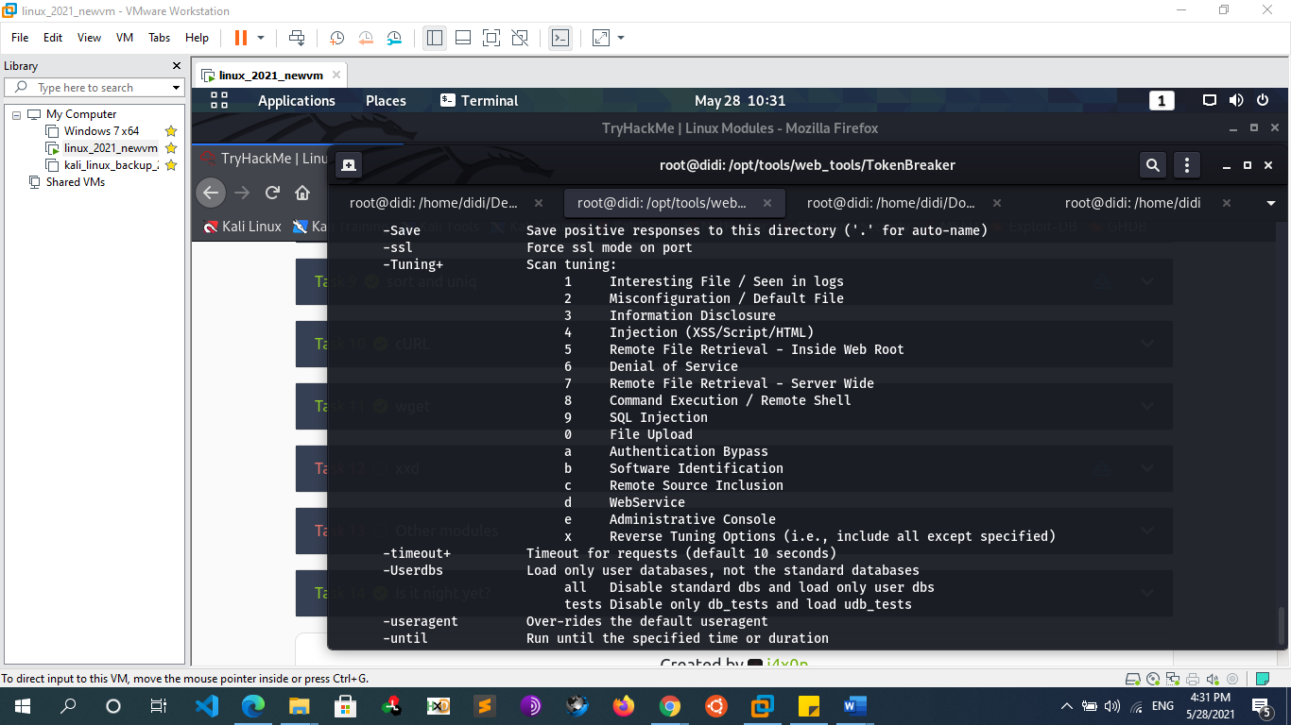
      * **W3af**
      * **Vega**
      * **Wapiti**
      * **Skipfish**
      * **Zed attack proxy (zap)**
      * **sqlmap**
      * **CMS Vulnerability Scanners**
        + **Wpscan**

wpscan --url [website]    -> to get info and possible vulnerabilities of the website

wpscan --url [website]  --enumerate u   -> to get the username of wp-panel

wpscan --url [website] --passwords passwd.txt --usernames [user found]

 -> bruteforce to get the password

* + - * + **joomscan**

joomscan -u [website]

joomscan -u [website]--enumerate-components

* + **Dns Scanning & Enumeration** 
    - **Host**
      * Host [[domain]](http://www.psasquashtv.com)
        + Forward dns lookup
      * Host [ip]
        + Host -t PTR [ip]
        + reverse dns lookup
      * Host –t { ns,mx,soa,A,AAAA,txt,any } [[domain]](http://www.psasquashtv.com)
      * Host –a [[domain]](http://www.psasquashtv.com)
        + -> -a = -V –t any
      * Host –a -v [[domain]](http://www.psasquashtv.com)
        + -> -v = -d = verbose
    - **Nslookup**
      * nslookup [[domain]](http://www.psasquashtv.com)
        + forward lookup
      * nslookup [ip]
        + reverse dns lookup
      * nslookup [[domain]](http://www.psasquashtv.com) [Name server]
        + using specific dns server
      * nslookup –query={any,mx,ns,soa} [[domain]](http://www.psasquashtv.com)
      * nslookup -timeout=10 [[domain]](http://www.psasquashtv.com)
        + change default timeout to wait for reply
      * nslookup –debug [[domain]](http://www.psasquashtv.com)
    - **Dns Automation Tools**
      * **Dig**
        + **Dns Query**

dig google.com {A|AAAA|NS|MX|CNAME|ANY} +noall +answer

dig @8.8.8.8 sci.alexu.edu.eg A +norecurse

* + - * + **Zone Transfer**

dig [domain] NS

Dig @[nameserver] [domain] axfr ->try with all name server founds

* + - * **dnsrecon**
        + Dnsrecon –d [domain]
        + Dnsrecon –d [domain] -a
        + dnsrecon -d microsoft.com -t axfr
        + dnsrecon -d [domain] -t axfr
      * **Dnsenum**
        + Dnsenum -d [domain]
        + Dnsenum –enum [domain]
      * **Dnswalk**
        + Dnswalk [doamain.] -> dot in the end of the domain
        + dnswalk -adilrfFm [domain.]
      * **Fierce**
        + Fierce –dns [domain]
        + Fierce –dns [domain] –threads 10

->default threads = 1

* + - * **Dnstracer**
        + Dnstracer [domain]
      * **Dnsmap**
        + Dnsmap [domain]
      * **Nmap**
        + nmap --script=broadcast-dns-service-discovery 192.168.1.3

The script first sends a query for \_services.\_dns-sd.\_udp.local to get a list of services. It then sends a follow-up query for each one to try to get more information.

* + - * + nmap -T4 -p 53 --script dns-brute www.hackingarticles.in
    - **Dns Zone Transfer**
      * A zone transfer is basically a database replication between related DNS servers in which the zone file is copied from a master DNS server to a slave server. The zone file contains a list of all the DNS names configured for that zone. Zone transfers should only be allowed to authorized slave DNS servers but many administrators misconfigure their DNS servers, and in these cases, anyone asking for a copy of the DNS server zone will usually receive one. This is equivalent to handing a hacker the corporate network layout on a silver platter. All the names, addresses, and functionality of the servers can be exposed to prying eyes
      * **Example**
        + Host

Host -t ns [domain]

host -t ns megacorpone.com | cut -d " " -f 4

attempt zone transfer requests against all the DNS servers found in a given domain

Host –l [hostname] [name server]

host -l megacorpone.com ns1.megacorpone.com

host -l megacorpone.com ns2.megacorpone.com

…….

* + **Web application Enumeration**
    - **Content Discovery Vs Assets Discovery** 
      * **Assets Discovery**
        + Asset discovery consists of finding all the digital online assets owned by a particular company. For example: Google owns google.com, YouTube.com, nest.com (acquisition), and a ton of other assets that may be a part of their bug bounty program. You can usually find these through searching on Google, Crunchbase, or Wikipedia. Each of these assets have a domain and each domain may have its own subdomains. For example Google.com has mail.google.com, drive.google.com, cloud.google.com, store.google.com and more.

ip/domain names/subdomains/open ports/certificate transparency (crt.sh)

* + - * **Content Discovery**
        + Content discovery helps us to find additional/sensitive folders, endpoints (files), documentation, or features that may not be directly accessible on the site. This also includes finding administration panels, files with sensitive debug/diagnosis information, api documentation, or hidden features available to for users with higher privileges. This can be done by crawling the site using Burp Suite or by using other tools.
    - **Info gathering**
      * **Programing languages used**
        + Wappalyzer extension / whatweb / through error / inspecting extensions in URLs
      * **Web servers used**
        + Wappalyzer extension / whatweb / through error
      * **Database’s software used**
        + Wappalyzer extension / through error
      * **Server operating system**
        + Wappalyzer extension / NSE
    - **Subdomain Enumeration**
      * **Two main ways:**
        + **Subdomain scraping:**

Find subdomains referenced online somewhere

* + - * + **Subdomain brute forcing:**

Try to resolve subdomains based on a wordlist

* + - * **Subdomain Brute forcing**
        + **Sublist3r**

git clone https://github.com/aboul3la/Sublist3r

cd Sublist3r

pip install -r requirements.txt

python sublist3r.py -v -d [website] -o result.txt

* + - * + **Knokpy**

Git clone <https://github.com/guelfoweb/knock.git>

Python Knockpy.py [website]

Python Knockpy.py [website] -w subdomains.txt

* + - * + **Subfinder**

apt-get install golang

git clone https://github.com/subfinder/subfinder

go get github.com/subfinder/subfinder

cd subfinder

go build

./subfinder -d example.com -o result2.txt

* + - * + **Subbrute**

python subbrute.py [website]

* + - * + **Amass**

https://github.com/OWASP/Amass/releases

unzip amass\_v3.1.9\_linux\_amd64.zip

cd amass\_v3.1.9\_linux\_amd64

./amass enum --passive -d example.com -o result1.txt

./amass enum --active -d example.com -o result1.txt

amass intel -org yahoo -max-dns-queries 2500 | awk -F, '{print $1}' ORS=',' | sed 's/,$//' | xargs -P3 -I@ -d ','

amass intel -asn @ -max-dns-queries 2500

This is what the command does in detail:

Get a list of ASNs (Autonomous System Numbers) of the target organization (e.g. yahoo)

Extract only a list of AS numbers and separate them by comma

For each identified ASN, find list of domain names that are associated with the ASN

* + - * + **AssetFinder**

assetfinder --sub-only [example.com](http://example.com/) >example.txt

Ex: cat example.txt | httprobe | tee active.txt

* + - * + **Fierce**

Fierce -dns target.com

Fierce -dns target.com -wordlist <name.txt>

* + - * + **Gobuster**

the "dns" mode. This allows Gobuster to brute-force subdomains.

gobuster -m dns -u google.com -w /usr/share/wordlists/dirb/common.txt

-t [nb]: set threads number

**-fw option** to enable force processing parameter to continue the attack even if there is any Wildcard Domain

gobuster -m dns -u google.com -t 100 -w /usr/share/wordlists/dirb/common.txt -i

show subdomains with their ip

-cn : show their cname

* + - * + **WFUZZ**

Wfuzz -c -f sub-fighter -w wordlist.txt -u “http:// example.com” -H “HOST:FUZZ.example.com”

* + - * + **Dnsrecon**

dnsrecon -d microsoft.com -g

-g: perform Google enumeration with standard enumeration

* + - * + **Theharvester**

theharvester -d microsoft.com -b google -l 200 -f /root/Desktop/msresults.html

We will use google as the search engine, we will limit the results to 200, and also store the results into a HTML file

* + - * + **Recon-ng**

Netcraft Module

Show workspaces

Workspaces add google.com

Use netcraft

Show options

Set source google.com

Run

Show hosts

Resolve Module (find ip for each subdomain)

Use recon/hosts-hosts/resolve

Show options

Run

Show hosts

Freegeoip (find location of each server)

Use freegeoip

Show options

Run

Show hosts

Report

Use reporting/html

Show options

Set CREATOR omar

Set CUSTOMER Hackerone

Set FILENAME /root

run

* + - * **Virtual hosts scanning**
        + **Gobuster**

"vhost" Mode

the "vhost" mode. This allows Gobuster to brute-force virtual hosts. Virtual hosts are different websites on the same machine. In some instances, they can appear to look like sub-domains, but don't be deceived! Virtual Hosts are IP based and are running on the same server. This is not usually apparent to the end-user. On an engagement, it may be worthwhile to just run Gobuster in this mode to see if it comes up with anything. virtual hosts would be a good way to hide a completely different website if nothing turned up on your main port 80/443 scan.

Example

gobuster vhost -u http://example.com -w /usr/share/wordlists/SecLists/Discovery/DNS/subdomains-top1million-5000.txt

This will tell Gobuster to do a virtual host scan http://example.com using the selected wordlist

* + - **Websites Crawling** 
      * **What is Crawling?**
        + Crawling a website is the process of browsing a website in a methodical or automated manner to enumerate all the resources encountered along the way. It gives us the structure of the website we are auditing and an overview of the potential attack surface for our future tests. A crawler finds files and folders in a website because these appear in web page links, comments or forms.
        + Parallel to brute-forcing for sensitive assets, spidering can help you get a picture of a site that, without a sitemap
      * **Manually Crawling:**
        + try to browse the entire app in a normal way by visiting every link , submitting every form , without having to take notes or screenshots. Burp allows you to link your browser to the application's proxy, where it will then keep a record of all the pages you visit as you step through the site
        + **Sitemaps**

Comparable to geographical maps in real life, “Sitemaps” are just that - but for websites!

“Sitemaps” are indicative resources that are helpful for crawlers, as they specify the necessary routes to find content on the domain

The below illustration is a good example of the structure of a website, and how it may look on a "Sitemap":

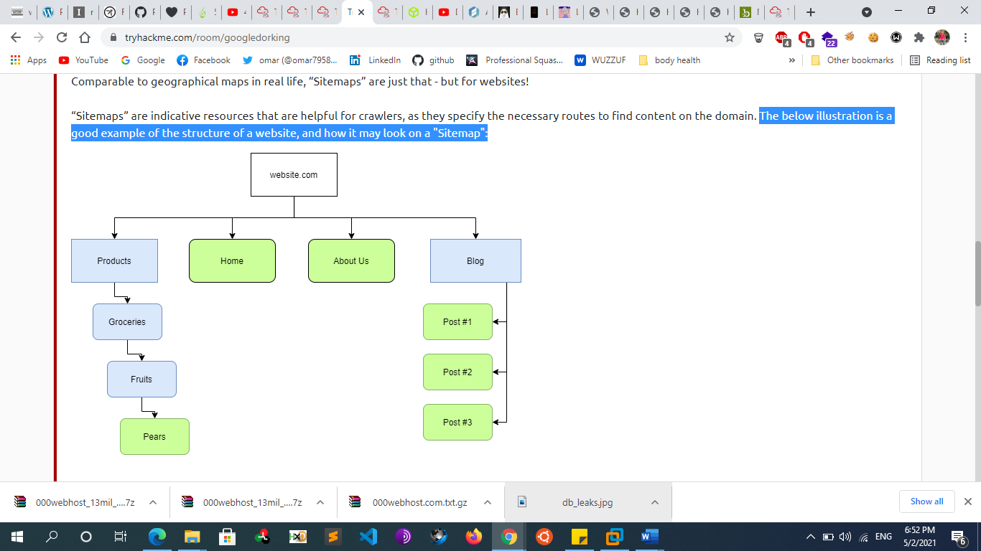

“Sitemaps” don't look like this in the real world. They look something much more similar to this:

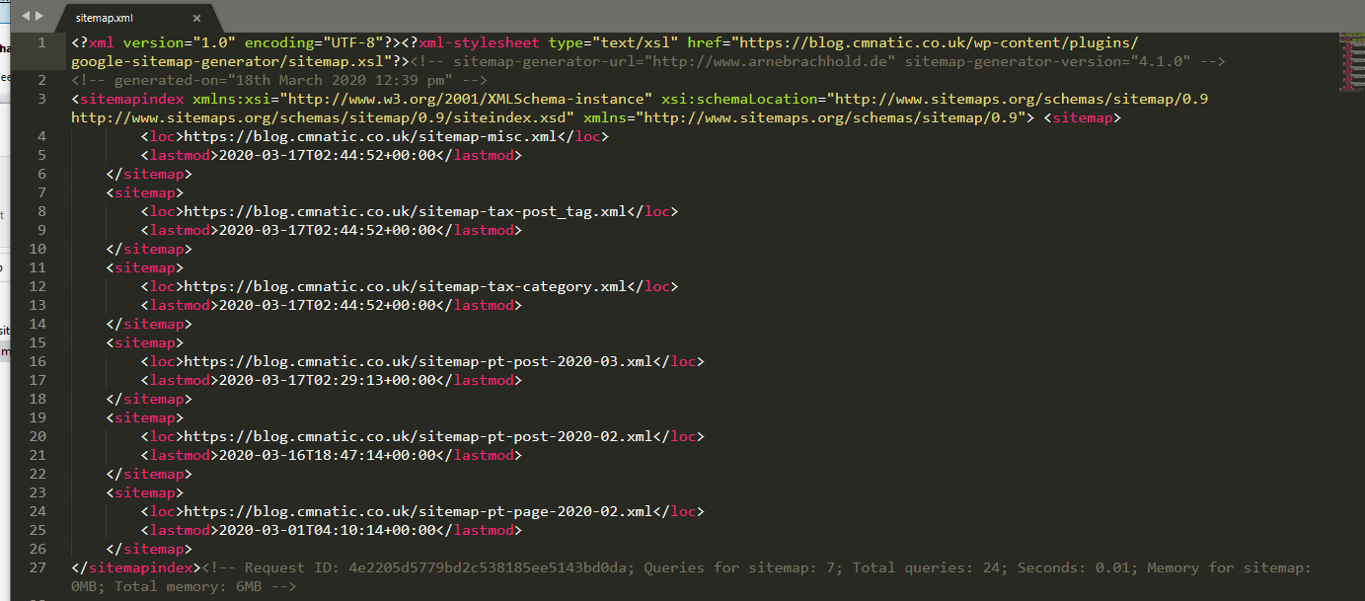

The presence of "Sitemaps" holds a fair amount of weight in influencing the "optimization" and favorability of a website. As we discussed in the "Search Engine Optimization" task, these maps make the traversal of content much easier for the crawler!  Resources like "Sitemaps" are extremely helpful for "Crawlers" as the necessary routes to content are already provided! All the crawler has to do is scrape this content - rather than going through the process of manually finding and scraping. Think of it as using a wordlist to find files instead of randomly guessing their names!

Sitemaps aren't always available d and they're always limited to what the site wants to show you d but they can be useful starting points for further investigation.

* + - * + **Robots.txt**

The robots.txt file is used to tell web spiders how to crawl a website. To avoid having confidential information indexed and searchable, webmasters often use this file to tell spiders to avoid specific pages. This is done using the keyword Disallow.

As an attacker, it's always a good idea to check the content of the robots.txt file and visit all the pages that are "disallowed" to find sensitive information

Ex :

user-agent: \* Disallow: /page.php

This means disallow indexing for this page for all user-agents

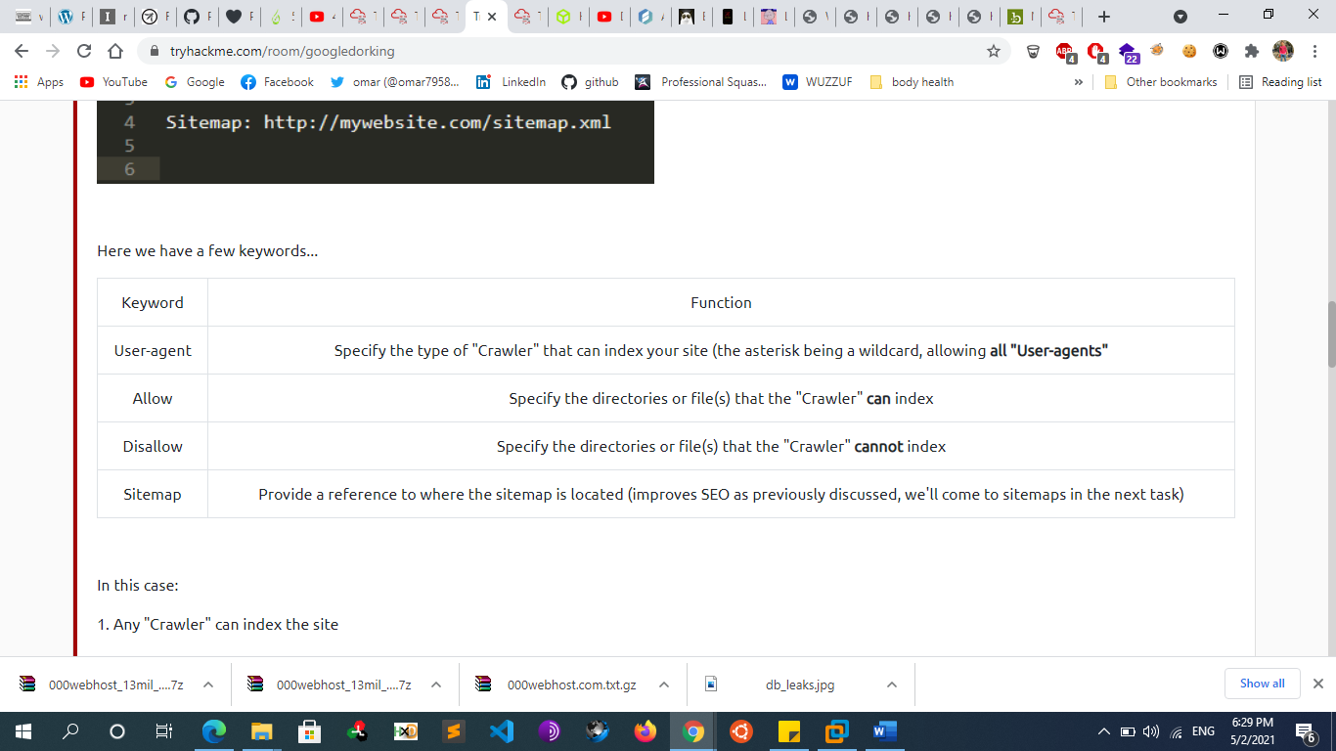

* + - * + **Locating Administration Consoles**

Web servers often ship with remote administration web applications, or consoles, which are accessible via a particular URL and often listening on a specific TCP port. Two common examples are the manager application for Tomcat and phpMyAdmin for MySQL hosted at /manager/html and /phpmyadmin respectively.

* + - * **Automatic Crawling:**
        + **Proxy Scanners**

burp spider or zap , webscarab

* + - * + **Metasploit**

use auxiliary/crawler/msfcrawler

msf auxiliary(msfcrawler) > set rhosts www.example.com

msf auxiliary(msfcrawler) > exploit

* + - **Directory Brute forcing**
      * **Wfuzz**
        + wfuzz -w ~/Code/SecLists/Discovery/Web-Content/SVNDigger/all.txt --hc 404 http://webscantest.com/FUZZ
        + python wfuzz.py -c -z file,wordlist/general/big.txt --hc 404 http://vulnerable/FUZZ

-c to output with colors.

-z file,wordlist/general/big.txt tells wfuzz to use the file wordlists/general/big.txt as a dictionary to brute force the remote directories' name.

--hc 404 tells wfuzz to ignore the response if the response code is 404 (Page not Found)

http://vulnerable/FUZZ tells wfuzz to replace the word FUZZ in the URL by each value found in the dictionary.

* + - * + wfuzz -c -w /usr/share/wfuzz/wordlist/general/megabeast.txt $ip:60080/?FUZZ=test
        + wfuzz -c --hw 114 -w /usr/share/wfuzz/wordlist/general/megabeast.txt $ip:60080/?page=FUZZ
        + wfuzz -c -w /usr/share/wfuzz/wordlist/general/common.txt "$ip:60080/?page=mailer&mail=FUZZ"
      * **ffuf**
        + apt install golang
        + git clone <https://github.com/ffuf/ffuf.git>
        + ffuf -w /usr/share/wordlists/dirbuster/directory-list.txt -u https//:target/FUZZ ->by using FUZZ keyword
      * **Dirsearch**
        + git clone <https://github.com/maurosoria/dirsearch.git>
        + ./dirsearch.py -u <http://testphp.vulnweb.com/>
        + **./dirsearch.py -u** [**[website]**](http://hostname.com) **-e php,html –x 400,401,403,404**
        + ./dirsearch.py -u [[website]](http://hostname.com) -e {aspx,php,…}
        + ./dirsearch.py -u [[website]](http://hostname.com) -e php –r

-> run recursively

* + - * + ./dirsearch.py -u [[website]](http://hostname.com) -e php,html –x 403,404 –r

-> exclude certain http response code

* + - * + ./dirsearch.py -u http://testphp.vulnweb.com/ -s 10

-s : delay between every request

* + - * + Output format

./dirsearch.py -u http://testphp.vulnweb.com/ --simple-report=report

./dirsearch.py -u http://testphp.vulnweb.com/ --plain-text-report=report

./dirsearch.py -u http://testphp.vulnweb.com/ --json-report=report

./dirsearch.py -u http://testphp.vulnweb.com/ --xml-report=report

./dirsearch.py -u http://testphp.vulnweb.com/ --markdown-report=report

./dirsearch.py -u http://testphp.vulnweb.com/ --csv-report=report

* + - * + ./dirsearch.py -u http://testphp.vulnweb.com/ -q

-q : remove unnecessarily banners

* + - * + ./dirsearch.py -u http://testphp.vulnweb.com/ -m HEAD

Change request method

* + - * **Dirbuster**
        + DirBuster is a file/directory brute-forcer. It's written in Java and programmed by the members of the OWASP community. It's a GUI application and comes with Kali Linux. DirBuster supports multithreading and is capable of brute-forcing targets at insane speeds.
        + https://www.hackingarticles.in/comprehensive-guide-on-dirbuster-tool/
      * **Gobuster**
        + Download

apt-get install gobuster

Dirbuster has a "dir" mode that allows the user to enumerate website directories. This is useful when you are performing a penetration test and would like to see what the directory structure of a website is

* + - * + gobuster dir -w /usr/share/wordlists/dirb/common.txt -u [ip]

**-o option : save result in a file**

**-e option** provides a more significant result, as it Prints complete URL when extracting any file or directories

**-r : follow redirection**

**-n Option** “no status” mode, it prints the output of the results without displaying the status code.

**-l option** enables content-length parameter which displays the size of the response. A Content-Length header is a number denoting and the exact byte length of the HTTP body for extracted file or directory.

* + - * + Gobuster dir -u [ip] -w /usr/share/wordlists/dirb/common.txt -x .php,.html

searches the given extension files

* + - * + gobuster dir -u [ip] -w /usr/share/wordlists/dirb/common.txt -q

quiet mode : disable banner

* + - * + gobuster dir -u [ip] -w /usr/share/wordlists/dirb/common.txt -a Mozilla/5.0 -fw

-a : specify a user agent

* + - * + gobuster dir -u [ip] -w /usr/share/wordlists/dirb/common.txt -s 200,301

show responses from these status codes

* + - * + gobuster dir -u [ip] dvwa -w /usr/share/wordlists/dirb/common.txt -f

appending a forward slash

* + - * + gobuster dir -u [ip] -w /usr/share/wordlists/dirb/common.txt -U test -P test

HTTP AUTHORIZATION Basic (-u username: password)

* + - * + gobuster dir -u http://192.168.1.108/ -w /usr/share/wordlists/dirb/common.txt –p 192.168.1.108:3129

use proxy

* + - * + **Gather subdomains**

the "dns" mode. This allows Gobuster to brute-force subdomains.

gobuster -m dns -u google.com -w /usr/share/wordlists/dirb/common.txt

-t [nb]: set threads number

**-fw option** to enable force processing parameter to continue the attack even if there is any Wildcard Domain

gobuster -m dns -u google.com -t 100 -w /usr/share/wordlists/dirb/common.txt -i

show subdomains with their ip

-cn : show their cname

* + - * **Dirb**
        + Dirb[http://example.com](http://INSERTIPADDRESS)
        + dirb [http://example.com](http://INSERTIPADDRESS) -r -o output.txt

-r : not recursive

The dirb scan, by default, scans the directories recursively. It means it scans a directory and then traverses inside that directory to scan for more subdirectories.

* + - * + dirb http://192.168.1.106/dvwa/ -X .php

searches the given extension files

* + - * + dirb http://192.168.1.106/dvwa/ -N 302

Ignore Unnecessary Status-Code

* + - * + dirb http://192.168.1.106/dvwa -z  100

there is some environment that cannot handle the flood created by the dirb scan, so it is important that we delay the scan for some time. -z : the time is provided on the scale of milliseconds

* + - * + dirb http://testphp.vulnweb.com/login.php -u  test:test

HTTP AUTHORIZATION Basic (-u username: password)

* + - * + dirb http://192.168.1.106/dvwa -H .php

**–H parameter** with specific extension, for example .php along with target URL it will enumerate all files or directories named with php

* + - * + dirb http://192.168.1.105/bwapp/portal.php -t

in order to run the dirb tool, we will have to add a forward slash (/) at the end of the URL to be accepted in dirb. In order to check that we need to try one attack on URL ending without any forward slash.

dirb http://192.168.1.105/bwapp/portal.php

You will observe that the scan doesn’t get executed successfully because of the lack of the forward slash, Try this attack once again with the same command with some changes so in order to run that command we have to add –t in the previous command.

* + - * + dirb http://192.168.1.108 –p 192.168.1.108:3129

-p : proxy

* + - * **Metasploit**
        + use auxiliary/scanner/http/brute\_dirs
        + use auxiliary/scanner/http/dir\_scanner
      * **Note**
        + The quality of the wordlists you're using to brute-force-discover hidden content is important. So clone the SecLists GitHub repository (a curated collection of fuzz lists, SQLi injection scripts, XSS snippets, and other generally malicious input)
  + **SSl scanning**
    - **Sslyze**
      * sslyze --regular [www.example.com](http://www.example.com)
    - **Sslscan** 
      * Sslscan [website]
    - **Nmap** 
      * nmap --script ssl-enum-ciphers -p [port] [hostname]
    - **tls-scan** 
      * tls-scan -c [[website]](http://search.yahoo.com) --all --pretty
    - **Testssl.sh**
      * git clone –depth 1 <https://github.com/drwetter/testssl.sh.git>
      * ./testssl.sh [website]
    - [**https://pentest-tools.com/network-vulnerability-scanning/ssl-tls-scanner**](https://pentest-tools.com/network-vulnerability-scanning/ssl-tls-scanner)
    - **Ssllabs.com**

**-> Nmap:**

* **Nmap network discovery**
  + **Overview**
    - On first connection to a target network in a black box assignment, our first objective is to obtain a "map" of the network structure -- or, in other words, we want to see which IP addresses contain active hosts, and which do not.
    - One way to do this is by using Nmap to perform a so called "ping sweep". This is exactly as the name suggests: Nmap sends an ICMP packet to each possible IP address for the specified network. When it receives a response, it marks the IP address that responded as being alive.
    - The -sn switch tells Nmap not to scan any ports -- forcing it to rely primarily on ICMP echo packets (or ARP requests on a local network, if run with sudo or directly as the root user) to identify targets. In addition to the ICMP echo requests, the -sn switch will also cause nmap to send a TCP SYN packet to port 443 of the target, as well as a TCP ACK (or TCP SYN if not run as root) packet to port 80 of the target.
  + **Example**
    - **nmap 192.168.1.1-255 –sn -> No Scan. List targets only**
    - **nmap 192.168.1.1-255 –sL -> No Scan. List targets only**
    - nmap 192.168.1.1-255 –pn -> Disable host discovery. Port scan only.
    - nmap 192.168.1.1-255 –pr ->arp discovery on local network
    - nmap 192.168.1.1-1/24 -PR -sn -vv
      * ->Arp discovery only on local network, no port scan
    - nmap 192.168.1.1-5 –PA 22-25,80
      * -> TCP Ack discovery on port x , port 80 by default
    - nmap 192.168.1.1-5 –PS 22-25,80
      * -> TCP SYN discovery on port x. , port 80 by default
    - nmap 192.168.1.1-3 –n
      * ->no dns resolution
* **Nmap port scanning**
  + 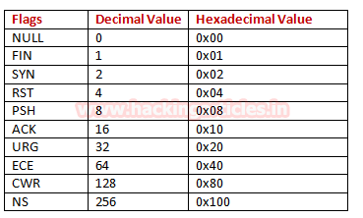
  + **Full Tcp Scan (connect scan)** 
    - Nmap 192.168.1.1 -p [port nb] -sT
      * Default technique if not root user
  + **Stealth Scan**
    - **Syn scan (half open scan)**
      * Nmap 192.168.1.1 -p [port nb] -sS
        + Default technique if root user
      * nmap 192.168.1.103 -p [nb] --scanflags 0x02
    - **Fin Scan**
      * Nmap 192.168.1.1 -p [port nb] -sF
      * nmap 192.168.1.103 -p [nb] --scanflags 0x01
    - **Null Scan**
      * Nmap 192.168.1.1 -p [port nb] -sN
      * nmap 192.168.1.103 -p [nb] --scanflags 0x00
    - **Xmas scan** 
      * Nmap 192.168.1.1 -p [port nb] -sX
      * nmap 192.168.1.103 -p [nb] --scanflags 0x29
  + **Ack Scan**
    - Nmap 192.168.1.1 -p [port nb] -sA
    - nmap 192.168.1.103 -p [nb] --scanflags 0x03
  + **Mainmon Scan**
  + **Udp Scan**
    - Nmap 192.168.1.1 -p [port nb] -sU
  + **Idle Scan**
  + **What if the port is open, but hidden behind a firewall?**
    - Many firewalls are configured to simply drop incoming packets. Nmap sends a TCP SYN request, and receives nothing back. This indicates that the port is being protected by a firewall and thus the port is considered to be filtered.
    - That said, it is very easy to configure a firewall to respond with a RST TCP packet. For example, in IPtables for Linux, a simple version of the command would be as follows:
      * **iptables -I INPUT -p tcp --dport <port> -j REJECT --reject-with tcp-reset**
    - This can make it extremely difficult (if not impossible) to get an accurate reading of the target(s).
* **Nmap timing**
  + T0 : paranoid ( intrusion Detection System evasion)
  + T1 : sneaky ( intrusion Detection System evasion)
  + T2 : polite ( slows down the scan to use less bandwidth and use less target machine resources)
  + T3 : normal default
  + T4 : agressive
  + T5 : insame
    - Ex : nmap -sX -p- 192.168.1.4 -T4
* **Target specification**
  + nmap 192.168.1.1    ->  scan a target
  + nmap 192.168.1.1 192.168.2.1  -> scan multiple targets
  + nmap 192.168.1.0/24    ->scan with cidr
  + nmap 192.168.1.1-255    -> scan range of addresses
  + nmap [nmap.domain.org](http://nmap.domain.org)    -> Scan a domain
  + nmap -iL targets.txt        -> scan targets from a file
  + nmap 192.168.1.0/24 --exclude 192.168.1.1  ->  exclude ip addresses
  + nmap 192.168.1.0/24 --excludefile hosts.txt    -> exclude ip addresses from file
* **Port specification**
  + nmap 192.168.1.1 -p 21 ->scan single port
  + nmap 192.168.1.1 -p 21,23,24 ->scan multiple ports
  + nmap 192.168.1.1 -p 21-50 ->scan range of ports
  + nmap 192.168.1.1 -p U:53,T:21-25,80   -> Port scan multiple TCP and UDP ports
  + nmap 192.168.1.1 -p- ->scan all 65535 ports
  + nmap 192.168.1.1 -p http,https -> scan ports by name
  + nmap 192.168.1.1 --top-ports 2000          -> Port scan the top x ports
  + nmap 192.168.1.1 -F                -> fast port scan (100 ports)
* **Saving Output**
  + 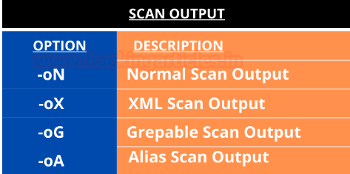
  + nmap -oA outputfile 192.168.1.1    ->all formats
  + nmap -oG outputfile 192.168.1.1  ->grepable format
  + nmap -oX outputfile 192.168.1.1    ->xml format
  + nmap -oN outputfile 192.168.1.1    ->txt format
  + nmap 192.168.3.5 ] outfile
* **Service & os detection**
  + nmap -sO 192.168.1.1 --osscan-guess -> Guess OS more aggressively
  + nmap -sO 192.168.1.1 --osscan-Limit
  + nmap -sV 192.168.1.1
  + nmap  -sV --version-intensity 5 192.168.1.1    -> More aggressive Service Detection  Intensity level range 0 to 9  Higher number increases possibility of correctness
  + nmap  -sV --version-all 192.168.1.1          ->Enable intensity level 9. Higher possibility of correctness. Slower
  + nmap  -sV --version-intensity 0 192.168.1.1
  + nmap 172.16.1.1 -sV --version-light           ->intensity level = 2
  + nmap -A 192.168.1.1
  + nmap 192.168.1.1 --reason   -> Display the reason a port is in a particular state, same as -vv
  + nmap 192.168.1.1 --open     ->show only open ports
* **Stealthy scan** 
  + **ftp bounce scan**
    - - The “-b” (FTP Bounce Scan) is another stealthy scan option we can use. Also known as an “FTP Bounce Attack”, this type of scan exploits an FTP servers’ “PORT” command and if an FTP server is vulnerable, allows us to launch port scans from the FTP server to other machines on the internet, or to even conduct scans against machines we don’t have direct access to on an internal network.
    - All scans using this method will appear to have originated from the FTP server, and is another great way to hide our true source**.**
* **Firewall Evasion** 
  + **Overview**
    - We have already seen some techniques for bypassing firewalls (think stealth scans, along with NULL, FIN and Xmas scans); **however, these techniques are not stealthy anymore**
    - Tools like Nmap offer options that can be used for this purpose however, it important to know that subverting IDS and firewalls systems takes both skills and experience.
      * **Decoys**
      * **Fragmentation**
      * **Timing**
      * **Source port**
    - Your typical Windows host will, with its default firewall, block all ICMP packets. This presents a problem: not only do we often use ping to manually establish the activity of a target, Nmap does the same thing by default. This means that Nmap will register a host with this firewall configuration as dead and not bother scanning it at all.
    - So, we need a way to get around this configuration. Fortunately, Nmap provides an option for this: -Pn, which tells Nmap to not bother pinging the host before scanning it. This means that Nmap will always treat the target host(s) as being alive, effectively bypassing the ICMP block; however, it comes at the price of potentially taking a very long time to complete the scan (if the host really is dead then Nmap will still be checking and double checking every specified port).
    - It's worth noting that if you're already directly on the local network, Nmap can also use ARP requests to determine host activity
    - There are a variety of other switches which Nmap considers useful for firewall evasion. We will not go through these in detail, The following switches are of particular note:
      * **-f:** Used to fragment the packets (i.e. split them into smaller pieces) making it less likely that the packets will be detected by a firewall or IDS.
      * **--mtu <number>** An alternative to -f, but providing more control over the size of the packets it accepts a maximum transmission unit size to use for the packets sent. This must be a multiple of 8.
      * **--scan-delay <time>ms**: used to add a delay between packets sent. This is very useful if the network is unstable, but also for evading any time-based firewall/IDS triggers which may be in place.
      * **--badsum:** this is used to generate in invalid checksum for packets. Any real TCP/IP stack would drop this packet, however, firewalls may potentially respond automatically, without bothering to check the checksum of the packet. As such, this switch can be used to determine the presence of a firewall/IDS.
  + **Examples**
    - nmap 192.168.1.1 -f
      * ->use tiny fragmented IP packets. Harder for packet filters
    - nmap 192.168.1.1 --mtu [size]
      * -> Set your own offset size
    - nmap --data-length 200 192.168.1.1
      * ->append random data to packets
    - nmap  192.168.1.1  --badsum
    - nmap -D decoy-ip1,decoy-ip2,decoy-ip3,decoy-ip4 remote-host-ip
      * ->send scanfrom spoof ips
    - nmap -S [spoof ip]   192.168.1.1
      * ->use spoof ip rather than your ip
    - Ex :nmap -f -t 0 -n -Pn –data-length 200 -D 192.168.1.101,192.168.1.102,192.168.1.103,192.168.1.23    192.168.1.1
* **Nmap scripting engine**
  + **Overview**
    - NSE Scripts are written in the *Lua*programming language, and can be used to do a variety of things: from scanning for vulnerabilities, to automating exploits for them. The NSE is particularly useful for reconnaisance
  + **Script’s location**
    - **We have two options** 
      * The first is the page on the Nmap website
        + https://nmap.org/nsedoc/
      * which contains a list of all official scripts. The second is the local storage on your attacking machine. Nmap stores its scripts on Linux at
        + /usr/share/nmap/scripts.
      * All of the NSE scripts are stored in this directory by default -- this is where Nmap looks for scripts when you specify them.
    - **There are two ways to search for installed scripts.** 
      * One is by using the script.db
        + /usr/share/nmap/scripts/script.db file.
      * Despite the extension, this isn't actually a database so much as a formatted text file containing filenames and categories for each available script.
      * Nmap uses this file to keep track of (and utilise) scripts for the scripting engine; however, we can also grep through it to look for scripts.
        + For example: grep "ftp" /usr/share/nmap/scripts/script.db.
      * The second way to search for scripts to use the ls command. For example, we could get the same results as in the previous screenshot by using
        + ls -l /usr/share/nmap/scripts/\*ftp\*:
  + **Categories of scripts (nse)** 
    - **safe**: Won't affect the target
    - **intrusive**: Not safe: likely to affect the target
    - **vuln**: Scan for vulnerabilities
    - **exploit**: Attempt to exploit a vulnerability
    - **auth**: Attempt to bypass authentication for running services (e.g. Log into an FTP server anonymously)
    - **brute**: Attempt to bruteforce credentials for running services
    - **discovery**: Attempt to query running services for further information about the network (e.g. query an SNMP server).
    - **Default**: run this set of scripts when -sC or -A without specifying a category
    - **Version**: detect the version of target s services
    - **Fuzzer**: sending a lot of data to target system to crash a service to find buffer overflow vuln
    - **dos**: may cause denial of service
    - Malware
    - External
    - Broadcast
  + **How NSE works**
    - To run a specific script, we would use **--script=<script-name>**
      * e.g. --script=http-fileupload-exploiter.
    - Multiple scripts can be run simultaneously in this fashion by separating them by a comma.
      * For example: **--script=smb-enum-users,smb-enum-shares.**
    - Some scripts require arguments (for example, credentials, if they're exploiting an authenticated vulnerability). These can be given with the **--script-args** Nmap switch. An example of this would be with the http-put script (used to upload files using the PUT method). This takes two arguments: the URL to upload the file to, and the file's location on disk. For example:
      * nmap -p 80 --script http-put --script-args http-put.url='/dav/shell.php',http-put.file='./shell.php'
    - Note that the arguments are separated by commas, and connected to the corresponding script with periods (i.e. <script-name>.<argument>)
    - Nmap scripts come with built-in help menus, which can be accessed using nmap **--script-help <script-name>.** This tends not to be as extensive as in the link given above, however, it can still be useful when working locally.
  + **Examples**
    - nmap [ip] -sC
      * -> -sC = = --script=default
    - nmap --script=vuln [ip]
      * ->will run all scripts in vuln category
    - /usr/share/nmap/scripts/smb\*
      * ->search all scripts related to smb
    - nmap --script smb-enum-users [ip]
    - nmap -v -p 139,445 --script=smb-os-discovery [ip]
      * -> os discovery and enum via smb
    - /usr/share/nmap/scripts/nfs\*
      * ->search all scripts to nfs enum
    - nmap -p 111 --script nfs\* 10.11.1.72
      * ->run all scripts with for nfs
    - nmap -p53 -sV --script dns-zone-transfer zonetransfer.me
    - nmap -p80 -sV --script http-robots.txt 8.8.8.8
    - nmap -p80 -sV --script http-vuln-\* 192.168.1.1
    - nmap -p21 -sV --script ftp-anon 192.168.1.1
    - nmap -p21 -sV --script ftp-vsftpd-backdoor 192.168.100.6
    - nmap -p139,445 -sV --script smb-os-discovery 192.168.1.1
    - nmap -p139,445 -sV --script smb-vuln\* 192.168.100.18
    - nmap -p139,445 -sV --script smb-check-vulns --script-args unsafe=1 192.168.1.243
    - nmap -sV -p 443 --script=ssl-heartbleed 192.168.1.0/24
  + **Defending against Nmap Scans**
    - The practice of security through obscurity doesn't work here. Whilst it may seem logical to attempt to hide a service by changing its port number to something other than the standard (such as changing SSH from port 22 to 2222), the service will still be fingerprinted during an Nmap scan (albeit slightly later on). Unfortunately, you cannot get the best of both worlds in having a service available yet hidden.
    - Fortunately, open-source Intrusion Detection (IDS) & Prevention Systems (IPS) such as Snort and Suricata allows blue-teamers to protect their networks using network monitoring. For example, you would install these services on firewalls such as pfSense
    - If they properly configured, a majority of Nmap scans can be detected. This is especially true when using an aggressive timing template such as -T4 or -T5 and also can block the ip address scanning the network

**->masscan:**

“Fastest port scanner can scan the whole internet in 6 mins “

* **port specification**
  + masscan 10.11.0.0/16 -p443    -> simple port scan
  + masscan 10.11.0.0/16 -p443,80,52    -> multiple port scan
  + masscan 10.11.0.0/16 -p22-25    -> range of ports
  + masscan 10.11.0.0/16 ‐‐top-ports 100    -> scan top ports
  + masscan 10.11.0.0/16 –p 0-65535 ––rate 1000000    -> scan all ports in network
* **scan rate** 
  + By default, masscan scans at a rate of 100 packets per second
  + masscan 10.11.0.0/16 ‐‐top-ports 100 ––rate 100000
  + masscan 0.0.0.0/0 -p443 ––rate 10000000  -> scan the whole internet for a specific port
  + masscan 0.0.0.0/0 -p0-65535 ––rate 10000000  ->  scan the whole internet for all ports
* **Saving Result** 
  + masscan 10.11.0.0/16 ‐‐top-ports 100 ‐‐echo > scan.txt
  + masscan 10.11.0.0/16 ‐‐top-ports 100 ] scan.txt
  + masscan 10.11.0.0/16 ‐‐top-ports 100  -oX result.xml
* **Other options**
  + masscan 10.11.0.0/16 ‐‐top-ports 100 --exclude=10.11.0.5 --max-rate 100000
    - -> exclude ips out of scan
  + masscan 10.11.0.0/16 ‐‐top-ports 10 --excludefile exclude.txt --max-rate 100000
    - -> exclude ips from file out of scan
  + masscan -iL ips-online.txt --rate 10000 -p1-65535 --only-open -oL masscan.out
    - -> scan ips from a file
  + masscan -e eth0 -p1-65535,U:1-65535 10.10.10.97 --rate 1000
    - -> specify the interface + udp scan
  + nmap -sV IP\_ADDRESS -oX scan.xml && xsltproc scan.xml -o "`date +%m%d%y`\_report.html"
    - -> generating a nice report

**ENUMERATION**

* 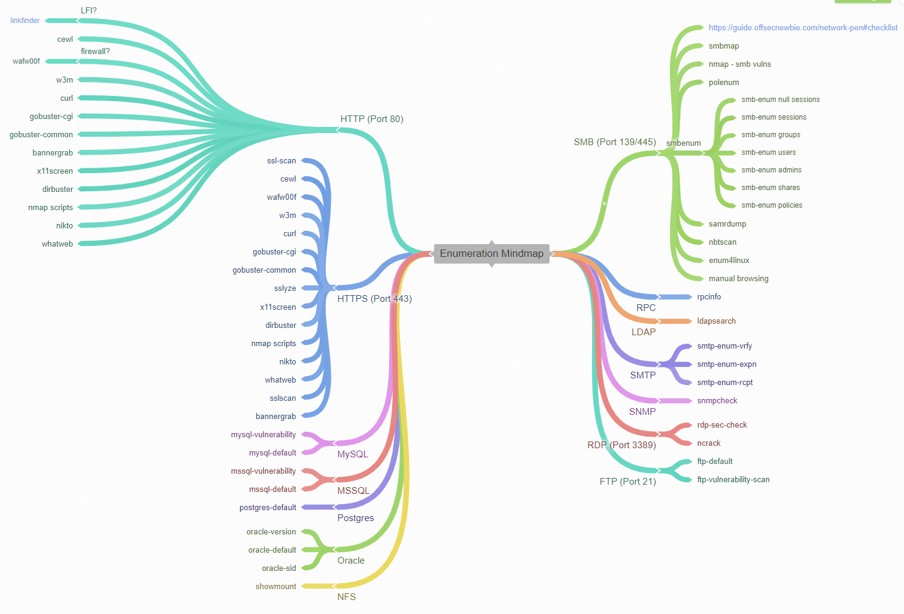
* **Introduction**
  + Enumeration is defined as the process of extracting user names, machine names, network resources, shares and services from a system. In this phase, the attacker creates an active connection to the system and performs directed queries to gain more information about the target. The gathered information is used to identify the vulnerabilities or weak points in system security and tries to exploit in the System gaining phase.
  + **Types of information enumerated by intruders:** 
    - Network Resource and shares
    - Users and Groups
    - Routing tables
    - Auditing and Service settings
    - Machine names
    - Applications and banners
    - SNMP and DNS details
  + **Techniques for Enumeration**
    - **TCP 53: DNS Zone transfer**
    - **TCP 135: Microsoft RPC Endpoint Mapper**
    - **TCP 137: NetBIOS Name Service**
    - **TCP 139: NetBIOS session Service (SMB over NetBIOS)**
    - **TCP 445: SMB over TCP (Direct Host)**
    - **UDP 161: SNMP**
    - **TCP/UDP 389: LDAP**
    - **TCP/UDP 3368: Global Catalog Service**
    - **TCP 25: Simple Mail Transfer Protocol (SMTP)**
* **SNMP Enumeration (port 161 , 162)**
  + **Introduction**
    - SNMP (Simple Network Management Protocol) is an application layer protocol which uses UDP protocol to maintain and manage routers, hubs and switches other network devices on an IP network. SNMP is a very common protocol found enabled on a variety of operating systems like Windows Server, Linux & UNIX servers as well as network devices like routers, switches etc. SNMP enumeration is used to enumerate user accounts, passwords, groups, system names, devices , apps , services on a target system. Using SNMP protocol
  + **SNMP consists of 3 major components:**
    - **1. Managed Device**: A managed device may be a device or a host (technically referred to as a node) that has the SNMP service enabled. These devices might be routers, switches, hubs, bridges, computers etc.
    - **2. Agent**: an agent are often thought of as a bit of software that runs on a managed device. Its primary job is to convert the data into SNMP compatible format for the graceful management of the network using SNMP protocol.
    - **3. Network Management System (NMS):** These are the software systems that are used for monitoring of the network devices.
    - 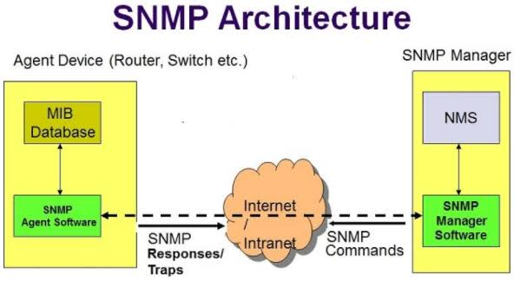
    - **Notes**:
      * An agent running on every SNMP device will be providing access to a read and writable database.  The database is referred to as the management information base (MIB) which is organized hierarchically and is a virtual database containing a formal description of all the network objects identified by a specific object identifier (OID) that can be managed using SNMP. It's a giant repository of values and settings. There is a manager involved in the process, and the manager will query the agent for various details.
        + MiB: Management information Base , it’s like a catalog of all things that I can monitor in network
        + OID: object identifier, every object in MIB has an OID it’s like an ID
      * Community strings is a password a text string used to authenticate communications between the management stations and network devices on which SNMP agents are hosted. Community Strings travel in clear text over the network, hence are subject to network sniffing attacks. Community Strings are sent with every network packet exchanged between the node and management station.
      * **Two types of community strings:**
        + **Read only**: This mode permits querying the device and viewing or reading the information, of device/system configuration but does not permit any kind of changes to the configuration. The default community string for this mode is “public.”
        + **Read Write**: In this mode, changes to the device are permitted; hence if one connects with this community string, we can even modify the remote device ’s configurations. The default community string for this mode is “private.”.
      * Default communities (passwords)
        + Public , private , community , cisco , manager
      * The main problem with SNMP is that the authentication method (public and private community strings) is inherently weak, not to mention the fact the SNMP is based on UDP, which is prone to spoofing. So, we’ve got a weak protocol, often forgotten and misconfigured – a disaster just waiting to happen.
      * the following MIB values correspond to specific Microsoft Windows SNMP parameters and contains much more than network-based information
        + 1.3.6.1.2.1.25.1.6.0 System Processes
        + 1.3.6.1.2.1.25.4.2.1.2 Running Programs
        + 1.3.6.1.2.1.25.4.2.1.4 Processes Path
        + 1.3.6.1.2.1.25.2.3.1.4 Storage Units
        + 1.3.6.1.2.1.25.6.3.1.2 Software Name
        + 1.3.6.1.4.1.77.1.2.25 User Accounts
        + 1.3.6.1.2.1.6.13.1.3 TCP Local Ports
  + **Tools for Enumeration**
    - **Metasploit (better result)**
      * auxiliary/scanner/snmp/snmp\_enum
      * auxiliary/scanner/snmp/snmp\_enum\_hp\_laserjet
      * auxiliary/scanner/snmp/snmp\_enumshares
      * auxiliary/scanner/snmp/snmp\_enumusers
      * auxiliary/scanner/snmp/snmp\_login
    - **Nmap**
      * nmap -sU -p161 --script snmp-brute 10.10.10.5,20
        + bruteforce to get the community strings
      * nmap -sU -p 161 --script=snmp-win32-services 10.10.10.5,20
        + list service running
      * nmap -sU -p 161 10.10.10.5,20 --script snmp-win32-users
        + enumerate users
    - **Onesixtyone**
      * Onesixtyone is an SNMP scanner that sends multiple SNMP requests to multiple IP addresses, trying different community strings and waiting for replies.to identify snmp servers
        + onesixtyone 192.168.1.125 -c /root/Desktop/community.txt
        + onesixtyone -c community.txt 192.168.1.244
        + onesixtyone -c community.txt -i ips.txt
    - **Snmpwalk**
      * Once we find SNMP server, we can start querying them for specific MIB data that might be interesting.
        + Enumerate the entire MIB Tree

snmpwalk -v1 -c [community\_string] 192.168.1.244

snmpwalk -v1 -c public 192.168.1.244

* + - * + This example enumerates the Windows users

snmpwalk -c public -v1 10.11.1.14 1.3.6.1.4.1.77.1.2.25

* + - * + This example enumerates the running processes

snmpwalk -c public -v1 10.11.1.73 1.3.6.1.2.1.25.4.2.1.2

* + - * + this enumerate installed softwares

snmpwalk -c public -v1 10.11.1.50 1.3.6.1.2.1.25.6.3.1.2

* + - * + This enumerate Open Tcp ports

snmpwalk -c public -v1 10.11.1.14 1.3.6.1.2.1.6.13.1.3

* + - * the output of snmpwalk is difficult and messy so use Metasploit module that gives better results
    - **snmpenum**
      * snmpenum -t 192.168.1.5
    - **Snmpset**
      * snmpset -v1 -c private 10.0.2.10 iso.3.6.1.2.1.1.5.0 s Hacked
    - **Snmp-check**
      * snmpcheck -t 192.168.1.5 -c public
  + **Countermeasures:**
    - Remove or disable SNMP agents on hosts
    - Block port 161 at all perimeter network access devices
    - Restrict access to specific IP addresses
    - Use SNMPv3 (more secure)
    - Implement the Group Policy security option called "Additional restrictions for anonymous connections"
    - Access to null session pipes, null session shares, and IPsec filtering should also be restricted
* **Smtp Enum (port 25) | pop3 (port 110)**
  + **Overview**
    - **What is SMTP**
      * SMTP stands for "Simple Mail Transfer Protocol". It is utilised to handle the sending of emails. In order to support email services, a protocol pair is required, comprising of SMTP and POP/IMAP. Together they allow the user to send outgoing mail and retrieve incoming mail, respectively.
      * The SMTP server performs three basic functions:
        + It verifies who is sending emails through the SMTP server.
        + It sends the outgoing mail
        + If the outgoing mail can't be delivered it sends the message back to the sender
      * **We can also gather information about a host or network from vulnerable mail servers.**
    - **POP and IMAP**
      * POP, or "Post Office Protocol" and IMAP, "Internet Message Access Protocol" are both email protocols who are responsible for the transfer of email between a client and a mail server. The main differences is in POP's more simplistic approach of downloading the inbox from the mail server, to the client. Where IMAP will synchronise the current inbox, with new mail on the server, downloading anything new. This means that changes to the inbox made on one computer, over IMAP, will persist if you then synchronise the inbox from another computer. The POP/IMAP server is responsible for fulfiling this process.
    - **Smtp commands** 
      * **HELO** – This is the command that the client sends to the server to initiate a conversation. Generally, the IP address or domain name must accompany this command, such as HELO 192.168.101 or HELO [client.microsoft.com](http://client.microsoft.com/).
      * **EHLO** – This command is the same as HELO, but communicates to the server that the client wants to use Extended SMTP. If the server does not offer ESMTP, it will still recognize this command and reply appropriately.
      * **STARTTLS** – Normally, SMTP servers communicate in plaintext. To improve security, the connection between SMTP servers can be encrypted by TLS (Transport Layer Security). This command starts the TLS session.
      * **RCPT** – Specifies the email address of the recipient.
      * **DATA** – Starts the transfer of the message contents.
      * **RSET** – Used to abort the current email transaction.
      * **MAIL** – Specifies the email address of the sender.
      * **QUIT** – Closes the connection.
      * **HELP** – Asks for the help screen.
      * **AUTH** – Used to authenticate the client to the server.
      * **VRFY** – Asks the server to verify is the email user’s mailbox exists.
  + **VERIFY users manually with telnet**
    - We can also gather information about a host or network from vulnerable mail servers. The Simple Mail Transport Protocol (SMTP) supports several interesting commands, such as VRFY and EXPN. A VRFY request asks the server to verify an email address, while EXPN asks the server for the membership of a mailing list. These can often be abused to verify existing users on a mail server, which is useful information during a penetration test
      * telnet 192.168.1.104 25
        + or nc 192.168.1.104 25
    - The SMTP service has two internal commands that allow the enumeration of users: VRFY (confirming the names of valid users) and EXPN (which reveals the actual address of user’s aliases and lists of e-mail (mailing lists)). Through the implementation of these SMTP commands can reveal a list of valid users.
      * VRFY [user]
        + Ex : VRFY root
      * USER [user]
      * EXPN [user]
        + You can guess for valid user account through the following command and if you receive response code **550** it means unknown user account: but If you received a message **code 250,251,252** which means the server has accepted the request and user account is valid.
  + **Tools For Enumeration**
    - **Smtp-user-enum**
      * **smtp-user-enum** is a tool for enumerating OS-level user accounts on Solaris via the SMTP service (sendmail). Enumeration is performed by inspecting the responses to VRFY, EXPN, and RCPT TO commands. It could be adapted to work against other vulnerable SMTP daemons, but this hasn’t been done as of v1.0.
        + smtp-user-enum -M VRFY -U users.txt -t 192.168.1.104

**-M:** mode Method to use for username guessing EXPN, VRFY or RCPT

**-U:** file File of usernames to check via SMTP service  
**-t:** host Server host running SMTP service

**-**w : nb of sec to wait until response

* + - **Nmap**
      * nmap --script=smtp-commands,smtp-enum-users,smtp-vuln-cve2010-4344,smtp-vuln-cve2011-1720,smtp-vuln-cve2011-1764 -p 25
    - **Metasploit** 
      * auxiliary/scanner/smtp/smtp\_version
        + get type of SMTP server and its name
      * auxiliary/scanner/smtp/smtp\_enum
      * auxiliary/scanner/smtp/smtp\_ntlm\_domain
      * auxiliary/scanner/smtp/smtp\_relay
      * Ex :
        + use auxiliary/scanner/smtp/smtp\_enum
        + msf auxiliary(smtp\_enum) > set rhosts 192.168.1.107
        + msf auxiliary(smtp\_enum) > set USER\_FILE /root/Desktop/user.txt
        + msf auxiliary(smtp\_enum) > exploit
    - **ISMPT**
      * **iSMTP** is the Kali Linux tool which is used for testing SMTP user enumeration (RCPT TO and VRFY), internal spoofing, and relay.
        + ismtp -h 192.168.1.107:25 -e /root/Desktop/email.txt

-h <host> The target IP and port (IP:port)

-e <file> Enable SMTP user enumeration testing and imports email list.

* + **Notes**
    - Okay, at the end of our Enumeration section we have a few vital pieces of information:
      * 1. A user account name
      * 2. The type of SMTP server and Operating System running.
    - If the ssh port is open we can use this info and bruteforce on the ssh with the usernames we got
      * hydra -t 16 -l USERNAME -P /usr/share/wordlists/rockyou.txt -vV 10.10.93.103 ssh
* **NFS Enumeration (port 2049)**
  + **Introduction**
    - The Network File System (NFS) protocol is used by Linux systems to share files and folders and is predominantly insecure in its implementation. It can be somewhat difficult to set up securely, so it’s not uncommon to find NFS shares open to the world
    - Network File System, or NFS, allows remote hosts to mount the systems/directories over a network. An NFS server can export a directory that can be mounted on a remote Linux machine. This allows the user to share the data centrally to all the machines in the network.
    - **RPC**
      * NFS uses *Remote Procedure Calls (RPC)* to route requests between clients and servers, meaning that the portmap service must be enabled and active at the proper runlevels
      * Both Portmapper and RPCbind run on TCP port 111. RPCbind maps RPC services to the ports on which they listen. RPC processes notify rpcbind when they start, registering the ports they are listening on and the RPC program numbers they expect to serve. The client system then contacts rpcbind on the server with a particular RPC program number. The rpcbind service redirects the client to the proper port number (often TCP port 2049) communicate with the requested service
      * 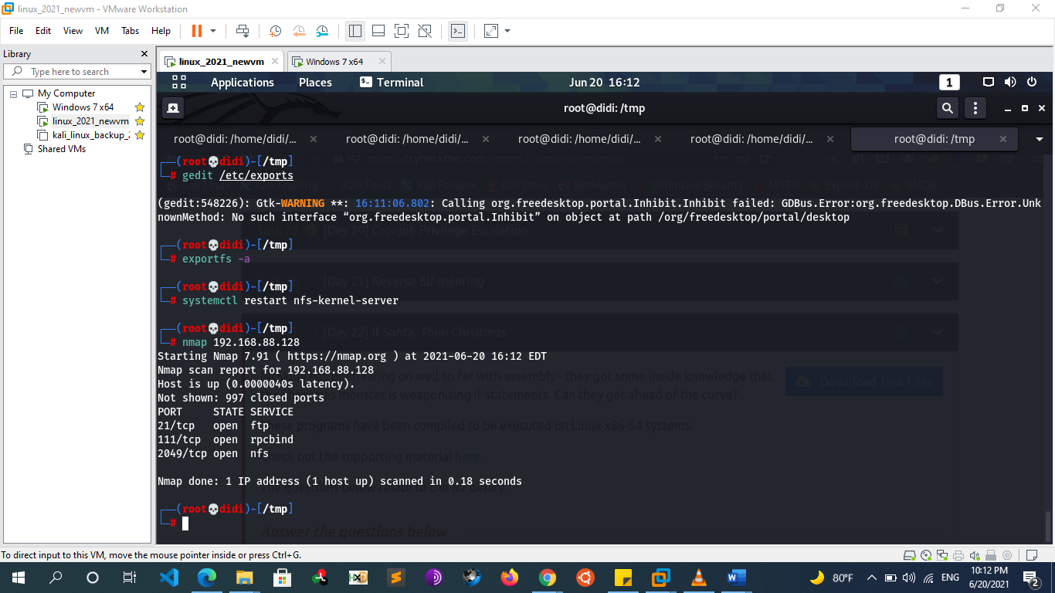
        + **Notice that port 111 [rpcbind] is open by default with nfs**
  + **Simulate Scenario**
    - To simulate the exact scenario,
      * sudo apt update
      * sudo apt install nfs-common nfs-kernel-server
    - I have modified the export directory from “/” (root) to “/home” under “/etc/exports” file. This file contains the configuration for NFS. After doing the changes, run the following command to restart the NFS service:
      * sudo mkdir -p /mnt/nfs\_share
      * sudo chmod 777 /mnt/nfs\_share/
      * sudo vim /etc/exports
        + /mnt/nfs\_share 192.168.1.0/24 (rw,sync,no\_subtree\_check)
      * sudo exportfs -a
      * sudo systemctl restart nfs-kernel-server
        + **ro**: With the help of this option we can provide **read only access** to the shared files i.e **client** will only be able to **read**.
        + **rw**: This option allows the **client server** to both **read** and **write** access within the shared directory.
        + **sync**: Sync confirms requests to the shared directory only once the **changes** have been committed.
        + **no\_subtree\_check**: This option prevents the **subtree** checking. When a shared directory is the subdirectory of a larger file system, **nfs** performs scans of every directory above it, in order to verify its permissions and details. Disabling the **subtree** check may increase the reliability of **NFS**, but reduce **security**.
        + **no\_root\_squash**: This phrase allows **root** to **connect** to the designated directory.
  + **Enumeration**
    - **Scan ports**
      * **nmap -sV [ip\_addr]**
      * nmap -sV --script=nfs-\* **[ip\_addr]**
    - **Check if any share is available for mount, using showmount tool**
      * showmount -e **[ip\_addr]**
    - **Mount the Shared Folder**
      * Create a new directory under the tmp folder of Kali and run the following command to mount the shared directory on this newly created directory.
        + mkdir /tmp/infosec
        + mount -t nfs 192.168.100.25:/shared /tmp/infosec
  + **Notes**
    - If /home directory is shared you have the whole system you can read the /etc/passwd
    - NFS can lead to exploitation if found ssh keys
      * Navigate to any user directory and locate the .ssh folder. This folder contains the public, private and authorized key for the SSH login for the specific user.
      * Cd /.ssh
        + The approach here will be to create own SSH keys and append the newly created public key into the authorized\_key of the victim user. Then log into the remote host with the victim user and own password.
      * Create ssh keys
        + Ssh-keygen
      * append the newly created public key into the authorized\_key
        + echo [content of newly generated public key] >> authorized\_keys
      * login to the vulnerable machine
        + SSH into the remote host from the Kali machine with user msfadmin and provide the path to the private key.
        + ssh -i pub\_rsa user@192.168.1.13

-i path to private key

* + - * if you get permission denied when you try to access .ssh then you cant get the public key of the user that’s because the user has changed the directory permissions
        + chmod 700 ~/.ssh
        + chmod 600 ~/.ssh/authorized\_keys
    - NFS can lead to privilege escalation with root squashing
* **SMB & NetBIOS Enum (port 135, 139, 445)**
  + **Introduction**
    - **Server Messaging protocol (SMB)** is the native file sharing protocol implemented in Windows systems. SMB uses share level and user level security to authorize access to file shares. **The Common Internet File System (CIFS)** protocol is a dialect of SMB which in turn is a collection of message packages that defines a specific version of SMB
      * **SMB version**
        + **CIFS**: The old version of SMB, which was included in Microsoft Windows NT 4.0 in 1996.
        + **SMB 1.0 / SMB1**: The version used in Windows 2000, Windows XP, Windows Server 2003 and Windows Server 2003 R2.
        + **SMB 2.0 / SMB2**: This version used in Windows Vista and Windows Server 2008.
        + **SMB 2.1 / SMB2.1**: This version used in Windows 7 and Windows Server 2008 R2.
        + **SMB 3.0 / SMB3**: This version used in Windows 8 and Windows Server 2012.
        + **SMB 3.02 / SMB3**: This version used in Windows 8.1 and Windows Server 2012 R2.
        + **SMB 3.1**: This version used in Windows Server 2016 and Windows 10.
        + Presently, the latest version of SMB is the SMB 3.1.1 which was introduced with Windows 10 and Windows Server 2016. This version supports AES 128 GCM encryption in addition to AES 128 CCM encryption added in SMB3, and implements pre-authentication integrity check using SHA-512 hash. SMB 3.1.1 also makes secure negotiation mandatory when connecting to clients using SMB 2.x and higher.
    - if you shared at least one file, you can observe that all 3 ports **port 135**, **139** and**445** get **activated**. Simultanesly
      * 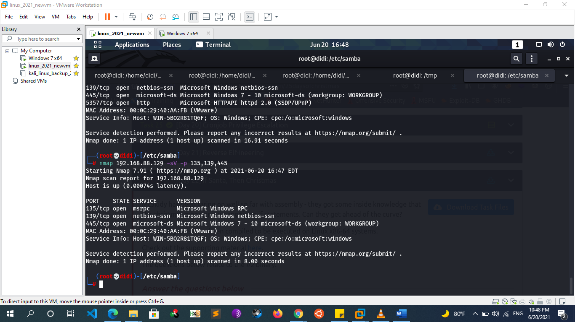
      * 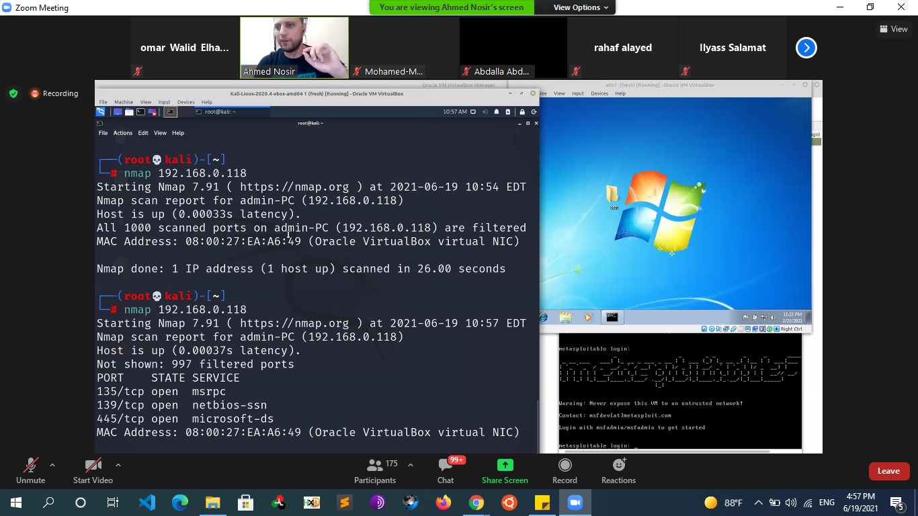
    - **Samba** 
      * is a Linux implementation of SMB, Samba is an open-source implementation of Microsoft Active Directory that allows non-Windows machines to communicate with a Windows network
      * 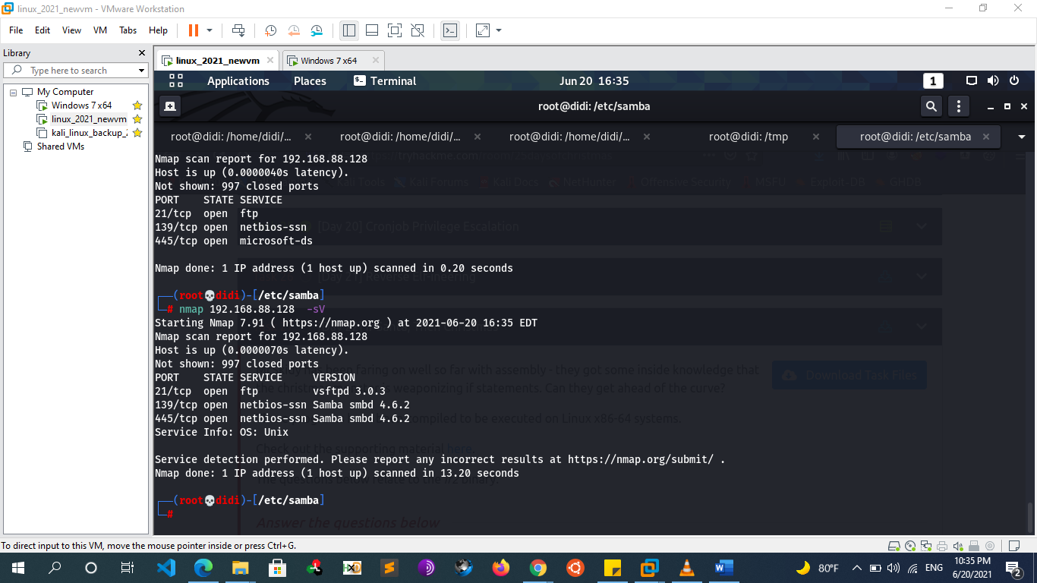
      * **Lab Setup Example**
        + apt-get install samba
        + cd /etc/samba/
        + rm smb.conf
        + touch smb.conf
        + nano smb.conf
        + [Name you want to get shown of the folder]

path = path of folder you want to share

browseable = yes

read only = no

* + - * + press ctrl+x then type “y” then hit enter.
        + add smbuser by the command

smbpasswd -a username

(username must be the user on linux os)

* + - * + start smbd and nmbd service

service smbd start

service nmbd start

* + **NETBIOS Enumeration**
    - **What is NetBIOS?**
      * NetBIOS stands for Network Basic Input Output System. It Allows computer communication over a LAN and allows them to share files and printers.
      * The main purpose of NetBIOS is to allow applications on different systems to communicate with one another over the LAN. It is used for a multitude of purposes including: sharing printers and files, remote procedure calls, exchange messages and much more. As expected, these features may reveal additional information such as computer names, user names, domains, printers, available shares...
      * PCs on a NetBIOS LAN communicate either by establishing a session or by using datagrams. To do this, NetBIOS uses the following TCP and UDP ports:
        + **UDP 137 for name services**

The name service has the same purpose of a DNS record, it translates and maps a NetBIOS name to an IP address.

NetBIOS name is an unique 16-byte address that identifies a NetBIOS resource on the network and is dynamically registered when either services or applications start. Names can be registered as unique names or as group names.

In order to locate a resource, a NetBIOS Name Query is used to resolve the NetBIOS name to an IP address. A name is composed of 16 characters: the firsts 15 characters can be specified by the user, while the 16th character is used to indicate the resource type [type of service running or name record type.] and goes from 00 to FF (hexadecimal).

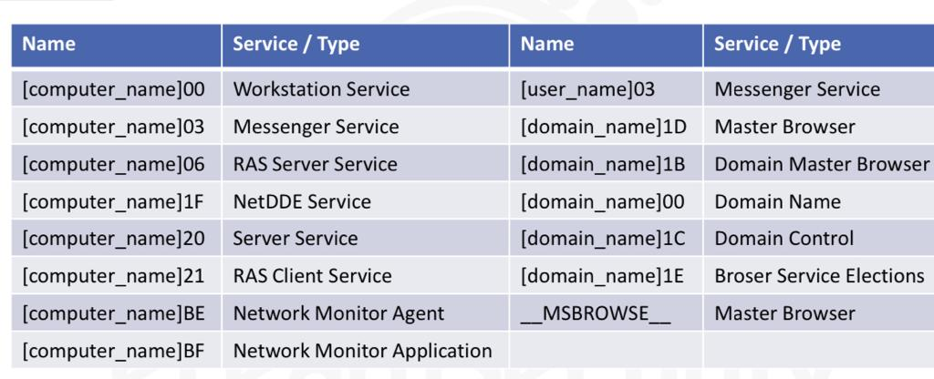

* + - * + **UDP 138 for datagram services**

The NetBIOS Datagram Service (NBDS) permits the sending of messages to a NetBIOS name. It runs on UDP port 138, therefore making it a connectionless communication.

The datagram service allows the sending and receiving of the datagram messages to and from:

a specific NetBIOS names

broadcast the datagram to all NetBIOS names

* + - * + **TCP 139 for session services**

The NetBIOS Session Service (NBSS) is the most commonly known of the NetBIOS services. It allows two names to establish a connection in order to exchange data.

For example, when a device creates a file sharing connection the session service is used. Once the session has been established, the two workstations use the Server Message Block (SMB) protocol

* + - * 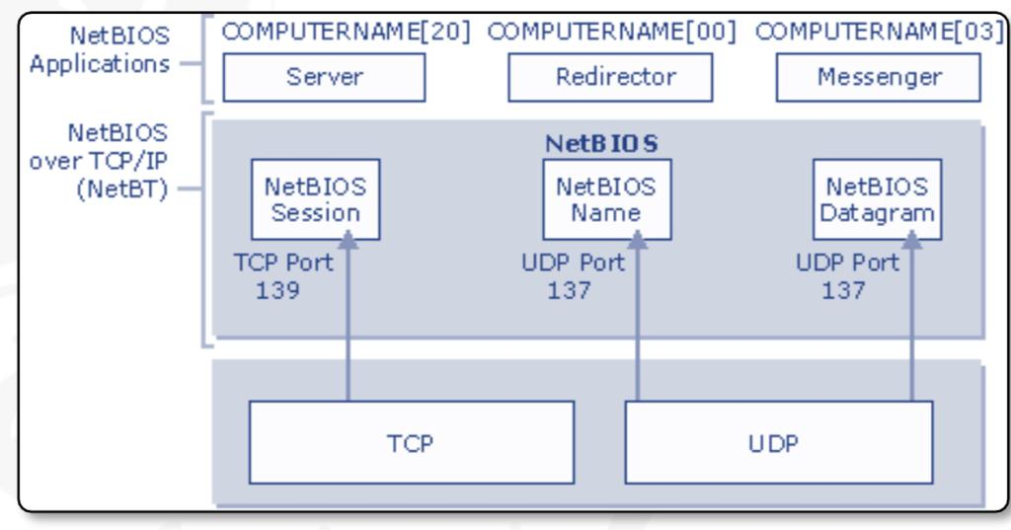
      * The NetBIOS service listens on TCP **port 139** as well as several UDP ports. It should be noted that SMB (TCP port 445) and NetBIOS are two separate protocols. NetBIOS is an independent session layer protocol and service that allows computers on a local network to communicate with each other. While modern implementations of SMB can work without NetBIOS, **NetBIOS over TCP (NBT) is required for backward compatibility and is often enabled together. For this reason, the enumeration of these two services often goes hand-in-hand**
      * Attackers use the NetBIOS enumeration to obtain:
        + List of computers that belong to a domain
        + List of shares on the individual hosts on the network
        + Policies and passwords
      * 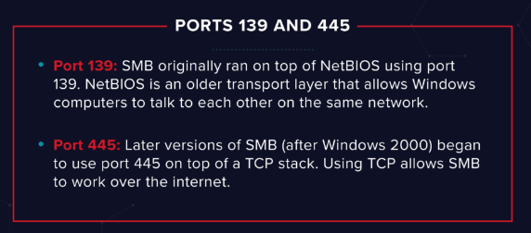
    - **Enumeration Tools:**
      * **Hostname**
        + We will start the enumeration of the SMB by finding the hostname of the target machine. This can be done by various tools. [this step can be done also in windows with nbtstat / ping tools]
        + **Nmblookup**

Usedto query NetBIOS names and map them to IP addresses in a network using NetBIOS

**For unique names:**

    00: Workstation Service (workstation name)

    03: Windows Messenger service

    06: Remote Access Service

    20: File Service (also called Host Record)

    21: Remote Access Service client

    1B: Domain Master Browser – Primary Domain Controller for a domain

1D: Master Browser

**For group names:**

    00: Workstation Service (workgroup/domain name)

    1C: Domain Controllers for a domain

    1E: Browser Service Elections

nmblookup -A 192.168.1.103

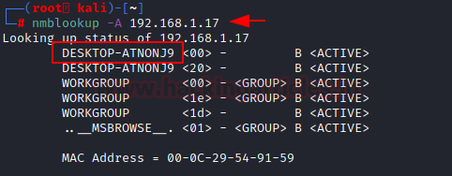

* + - * + **Nbttscan**

NBTscan is a program for scanning IP networks for NetBIOS name information. It sends NetBIOS status query to each address in supplied range and lists received information in human-readable form. For each responded host it lists IP address, NetBIOS computer name, logged-in user name and MAC address (such as Ethernet).and because it is a first step in finding open shares. It is created on the functionality of the Windows standard tool “nbtstat”,

nbtscan -r 192.168.1.0/24 -> who run smb

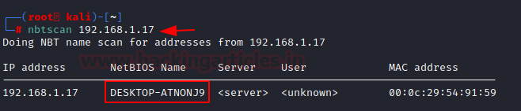

* + - * + **Nmap**

**nbstat NSE Script**

This nmap script attempts to retrieve the target’s NetBIOS names and MAC address. By default, the script displays the name of the computer and the logged-in user; if the verbosity is turned up, it displays all names the system thinks it owns. It also shows the flags that we studied in nmblookup tool.

nmap --script nbstat.nse 192.168.1.17

**NSE smb-os-discovery script**

This NSE script attempts to determine the operating system, computer name, domain, workgroup, and current time over the SMB protocol (ports 445 or 139). It is achieved by initiating a session with the anonymous account (or with a proper user account, if one is given; it likely doesn’t make a difference); in response to a session starting, the server will send back all this information.

The following fields may be included in the output, depending on the circumstances (e.g., the workgroup name is mutually exclusive with domain and forest names) and the information available:

OS

Computer name

Domain name

Forest name

FQDN

NetBIOS computer name

NetBIOS domain name

Workgroup

System time

nmap --script smb-os-discovery 192.168.1.13

* + **Share and smb Null Sessions**
    - As we discussed earlier that SMB works on sharing files and resources. In order to transfer these files or resources, there are data streams that are called shares. There are public shares that are accessible to everyone on the network and then there are the user-specific shares. Let’s enumerate these shares.
    - **Smbclient**
      * smbclient is a client that can ‘talk’ to an SMB/CIFS server. It offers an interface similar to that of the FTP program. It can upload/download files from and to smb server, retrieving directory information from the server and so on. List shares …etc
      * **List shares**
        + smbclient -L 192.168.01.13
        + smbclient -L 192.168.0.70

anonymous login

* + - * + smbclient -U TestUser -L 192.168.0.70

any folder end with “$” means that its hidden directory

* + - * **Access shares**
        + linux share

smbclient //192.168.0.70/tmp

anonumous user

smbclient -U TestUser //192.168.0.70/tmp

* + - * + windows share

smbclient [\\\\192.168.1.10\\share](file:///\\\\192.168.1.10\\share)

anonumous user

smbclient –U user [\\\\192.168.1.10\\share](file:///\\\\192.168.1.10\\share)

* + - * + 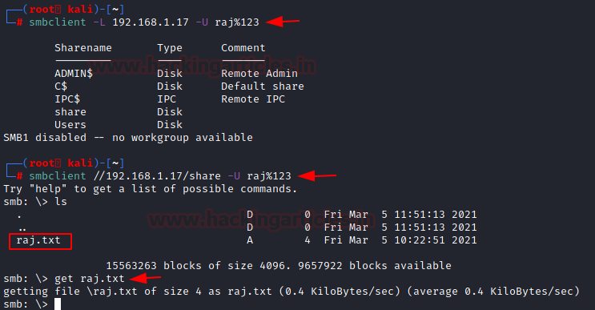
    - **Smbmap**
      * Same as smbclient allows us to enumerate samba share drives across an entire domain.
      * List shares, list drive permissions, share contents, upload/download functionality
      * **List shares**
        + smbmap -H 192.168.0.34
        + smbmap -u TestUser -p TestPass -H 192.168.0.34
        + smbmap -u TestUser -p [NTLM\_hash] -H 192.168.0.34
      * 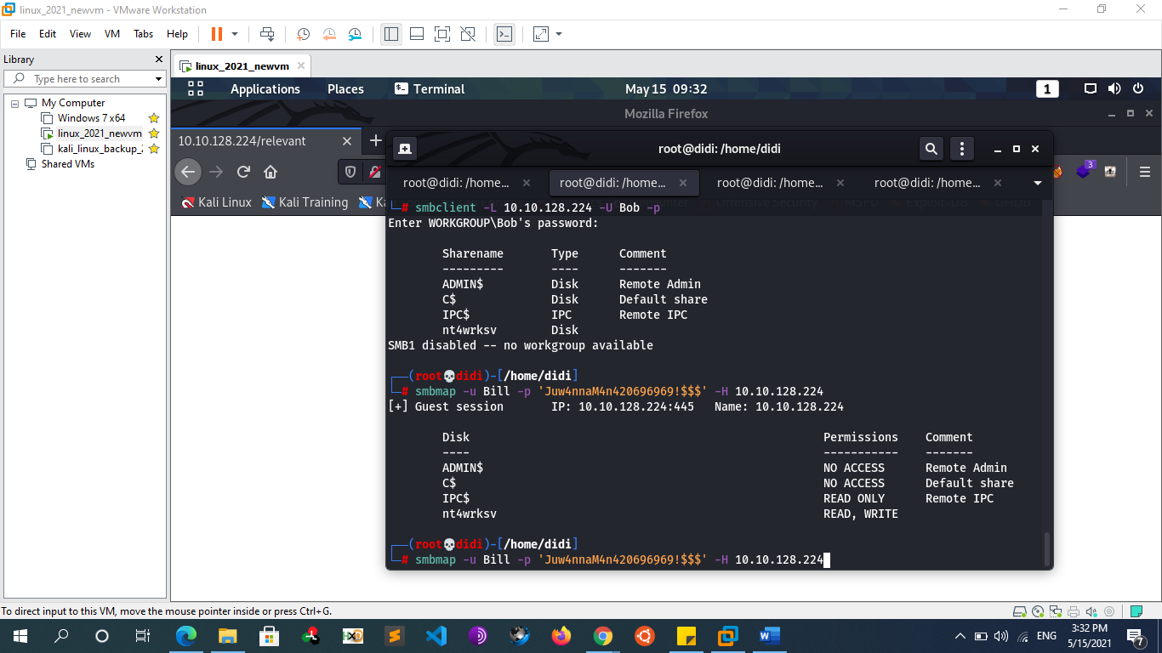
        + **You can see that we have write access so we can upload anything there**
    - **NMAP**
      * nmap -p139,445 [ip address]
      * nmap [ip address] –script=”smb-vuln\*” -p 139,445
      * nmap 192.168.1.13 -sV -p T:139,445 U:137 --script="smb-enum-\*"
      * nmap -p139,445 –script smb-enum-users [ip address]
      * nmap -p139,445 –script smb-enum-users –script-args=unsafe=1 [ip address]
    - **Automate with Metasploit**
      * auxiliary/scanner/smb/psexec\_loggedin\_users
      * auxiliary/scanner/smb/smb\_enumshares
      * auxiliary/scanner/smb/smb\_enumusers
      * auxiliary/scanner/smb/smb\_enumusers\_domain
      * auxiliary/scanner/smb/smb\_login
      * auxiliary/scanner/smb/smb\_lookupsid
        + The smb\_lookupsid module brute-forces SID lookups on a range of targets to determine what local users exist in the system. Knowing what users exist on a system can greatly speed up any further brute-force logon attempts later on.
      * auxiliary/scanner/smb/smb\_ms17\_010
      * auxiliary/scanner/smb/smb\_version
  + **Important Note**
    - * If Password Protected is turned on, we cannot access file shared without password if is turned off we can access file shared without password Ex:
      * 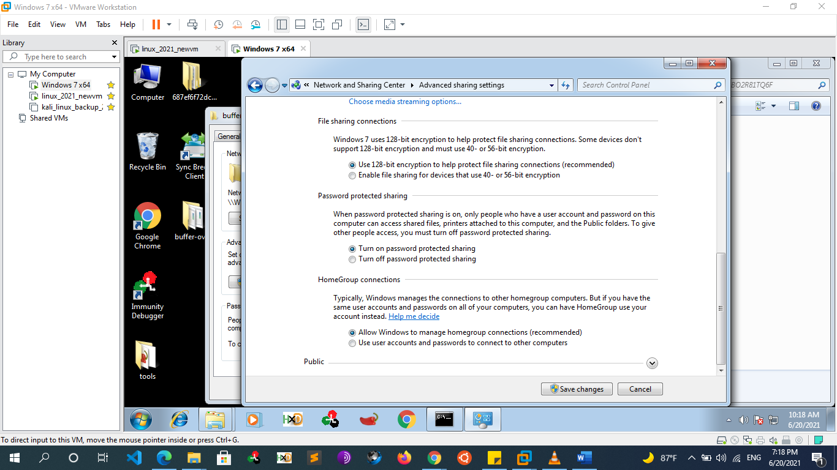
      * 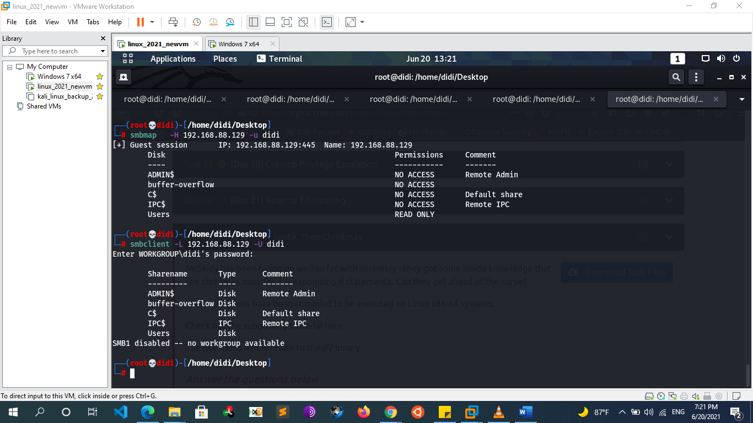
      * 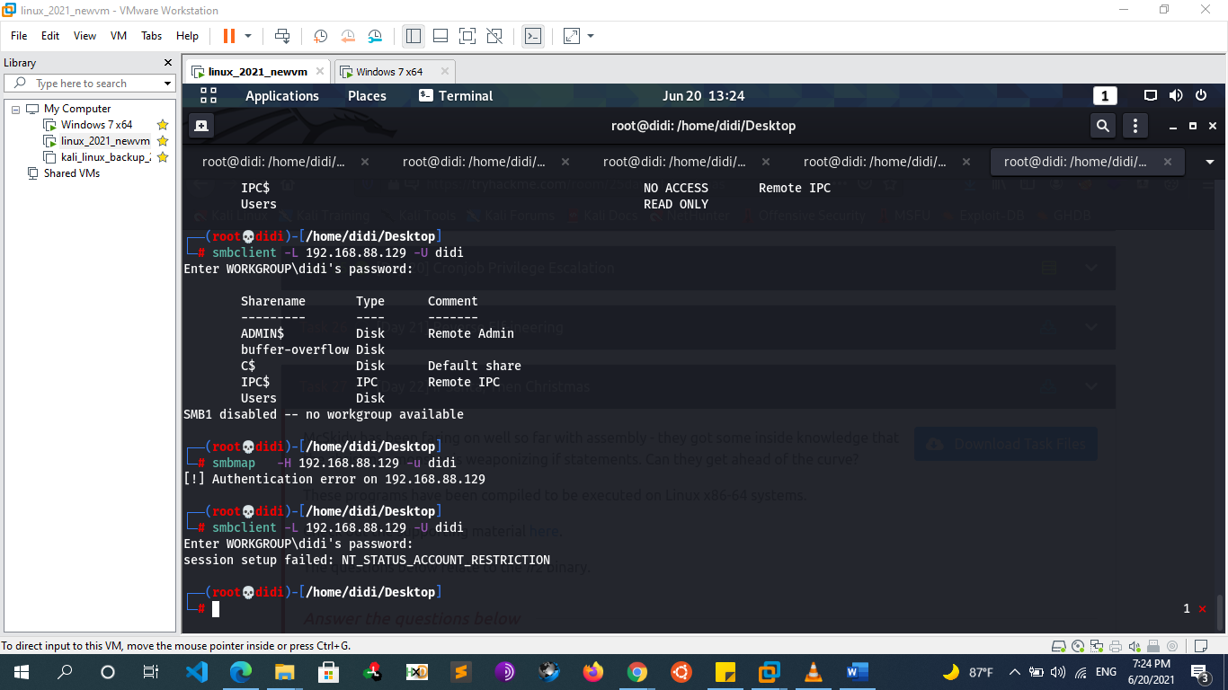
      * 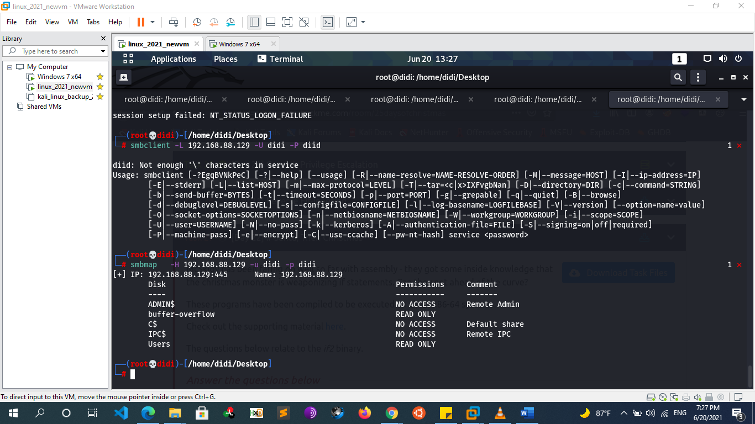
      * If have noticed that the shared folder has read permission, we can change this and add another permission
      * 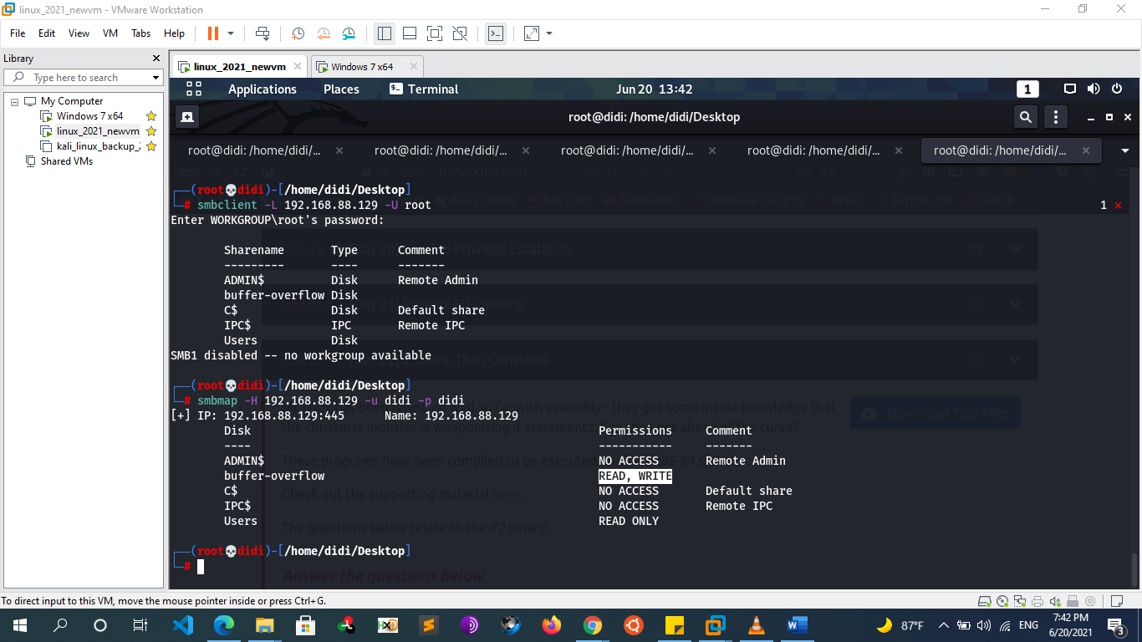
      * 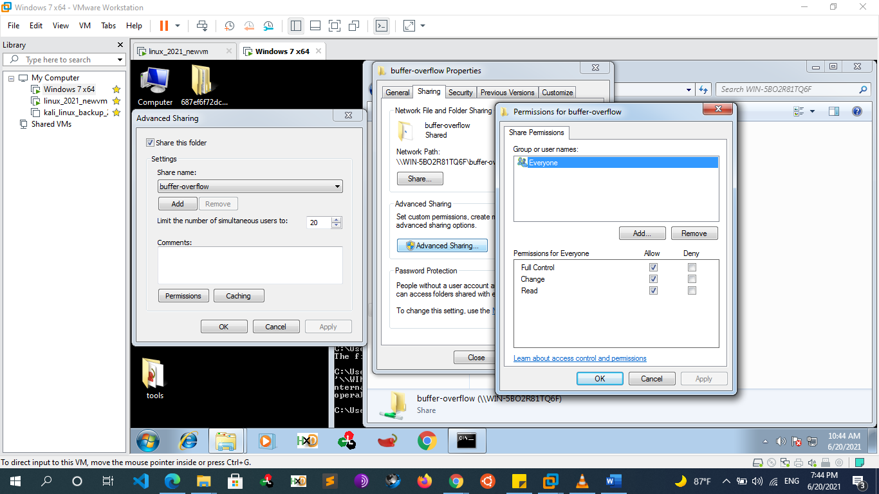
  + **User Enum via null session** 
    - **Remote Procedure Call (RPC) port 111**
      * Remote Procedure Call (RPC) is a protocol that one program can use to request a service from a program located in another machine on a network without having to understand the network’s details. A procedure call is also sometimes known as a function call or a subroutine call.
      * This is just a server that converts remote procedure call (RPC) program number into universal addresses. When an RPC service is started, it tells rpcbind the address at which it is listening and the RPC program number its prepared to serve
    - **Rpcclient**
      * Depending on the host configuration, the RPC endpoint mapper can be accessed through TCP and UDP port 135 (msrpc) or , via SMB with a null or authenticated session (TCP 139 and 445), and as a web service listening on TCP port 593.
      * rpcclient is a utility initially developed to test MS-RPC functionality in Samba itself.
      * rpcclient -U "" -N 10.0.2.4 -> null session
      * rpcclient -U "test" 10.0.2.4 -> session with user
        + rpcclient> srvinfo
        + rpcclient> enumdomusers -> get username as well as their rid
        + rpcclient> getdompwinfo
        + rpcclient> enumprivs
        + rpcclient> enumalsgroups domain
        + rpcclient> lookupnames administrators
        + rpcclient> querydominfo
        + rpcclient> queryuser user
    - **Rpcbind**
      * the **rpcbind** utility is a server that converts RPC program numbers into universal addresses. It must be running on the host to be able to make RPC calls on a server on that machine.
        + Rpcbind -p [ip]
    - **Rpcinfo**
      * Probe **rpcbind** on *host* using version 2 of the **rpcbind** protocol, and display a list of all registered RPC programs. If *host* is not specified, it defaults to the local host. Note that version 2 of the **rpcbind** protocol was previously known as the portmapper protocol.
        + Rpcinfo -p [ip]
  + **Overall Scan** 
    - **Enum4linux** 
      * is a tool for enumerating information from Windows and linux os that have Samba (SMB) working on their hosts? It is written in Perl and is basically a wrapper around the Samba tools smbclient, rpclient, net, and nmblookup (no interaction only enum)
      * can list users , shares , passwords policies , domain and group memberships
        + enum4linux –a [ip] -> run all scans
        + enum4linux -{U|S|P|G} 10.0.2.4
        + enum4linux -{U|S|P|G} -u TestUser -p TestPass 192.168.100.200

-U             get userlist  
-M             get machine list  
-N             get namelist dump (different from -U and-M)  
-S             get sharelist  
-P             get password policy information  
-G             get group and member list

-A             all of the above (full basic enumeration)

* **Ldap Enumeration**
  + **Nmap** 
    - nmap -n -sV --script "ldap\* and not brute" [IP]
      * ->Using anonymous credentials
  + **Ldapsearch**
    - ldapsearch -x -h [IP] -D '[DOMAIN]\[username]' -w '[password]' -b "CN=Users,DC=[1\_SUBDOMAIN],DC=[TDL]" -> extract users
    - ldapsearch -x -h [IP] -D '[DOMAIN]\[username]' -w '[password]' -b "CN=Computers,DC=[1\_SUBDOMAIN],DC=[TDL]" -> extract computers
    - ldapsearch -x -h [IP] -D '[DOMAIN]\[username]' -w '[password]' -b "DC=<1\_SUBDOMAIN>,DC=[TDL]"
      * -x Simple Authentication
      * -h LDAP Server
      * -D My User
      * -w My password
      * -b Base site, all data from here will be given
* **Ntp Enumeration:** 
  + **Introduction**
    - The Network Time Protocol is a protocol for synchronizing time across your network, this is especially important when utilizing Directory Services. There exists a number of time servers throughout the world that can be used to keep systems synced to each other. NTP utilizes UDP port 123. Through NTP enumeration you can gather information such as lists of hosts connected to NTP server, IP addresses, system names, and OSs running on the client system in a network. All this information can be enumerated by querying NTP server,
  + **Ntptrace**
  + **Ntpdc**
    - ntpdc -n –c monlist [IP or hostname of time server]
  + **Ntpq**
    - ntpq -c readlist [ip\_address]
    - ntpq -c readvar [ip\_address]
    - ntpq -c monlist [ip\_address]
    - ntpq -c peers [ip\_address]
    - ntpq -c listpeers [ip\_address]
    - ntpq -c associations [ip\_address]
    - ntpq -c sysinfo [ip\_address]
* **Automate scanning tools** 
  + **AUTORECON.PY**
    - Git clone https://github.com/Tib3rius/AutoRecon.git
    - **{** use enum4linux, gobuster,nbtscan,nikto,nmap,onesixtyone,oscanner,smbclient,smbmap,smtp-user-enum,snmpwalk,sslscan,svwar,tnscmd10g,whatweb,wkhtmltoimage ,…**}**